Thursday 4th March
World Book Day

Today we are going to be completing activities linked to the book:

The Boy, the Mole, the Fox and the Horse by Charlie Mackesy.

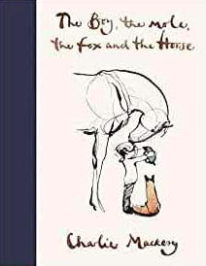

This is a beautifully illustrated book with a lovely message about life and friendship.
Head over to the videoblog to watch the book reading.
Think about the following:
How does the book make you feel?
What is your favourite bit? Why?
What do you like about the pictures?

Choose 3 Activities to complete.

Activity 1:

Look at the pictures and quotes below:

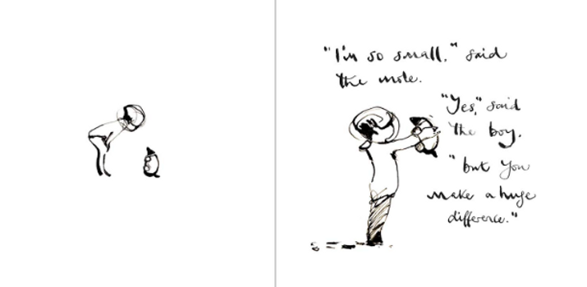
What does the boy mean when he says: ‘but you make a huge difference’?

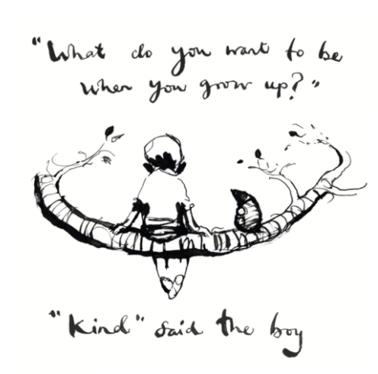
Why does he say this?

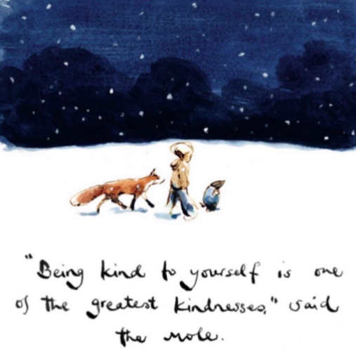

How can you be kind to yourself?

Task: look at the mind map below:

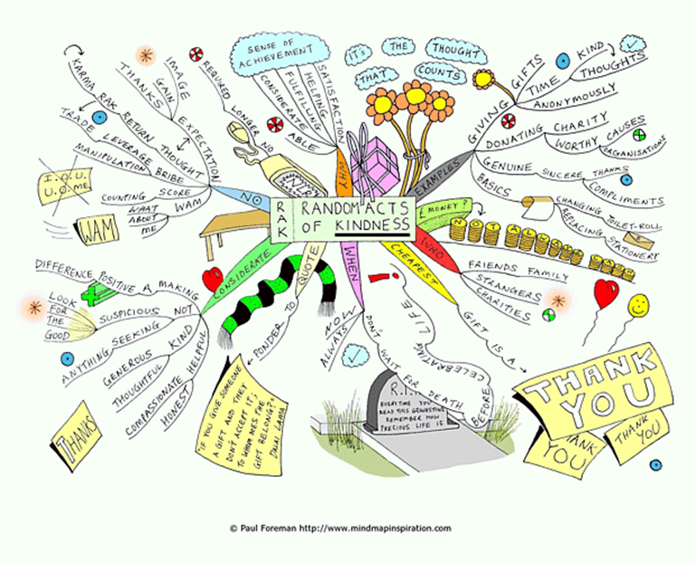

Create your own mind map.
Link it to one of the following themes:

- Home

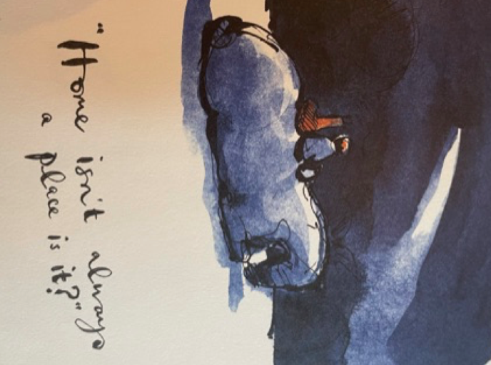

- Beauty
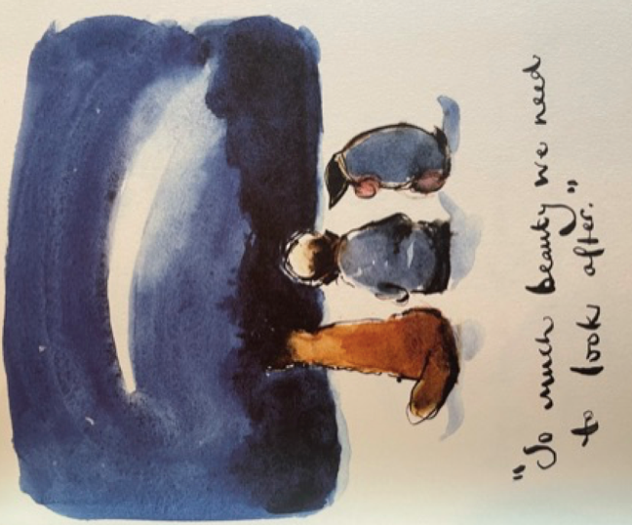

- Bravery
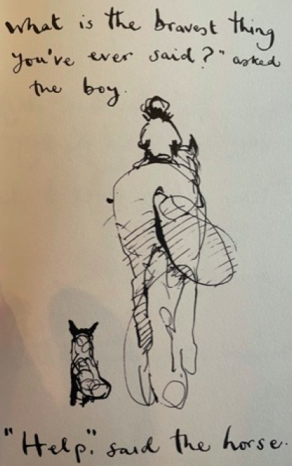

Or make it personal – what makes you extraordinary?

Activity 2:

Create a recipe for kindness.

What ingredients would you need? E.g. a spoonful of love, a pinch of thoughtfulness
What instructions would you give? E.g. mix the spoonful of love with a pinch of thoughtfulness.
Illustrate your recipe.

A Recipe for Kindness

Ingredients:

Method:

6.

Activity 3:

Create your own page of the book.
Come up with a quote or question and write it in the same style. Illustrate your quote.
Here are some to inspire you:

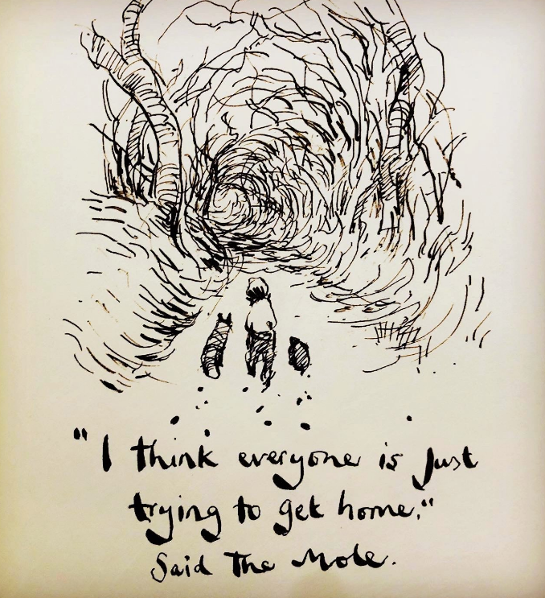
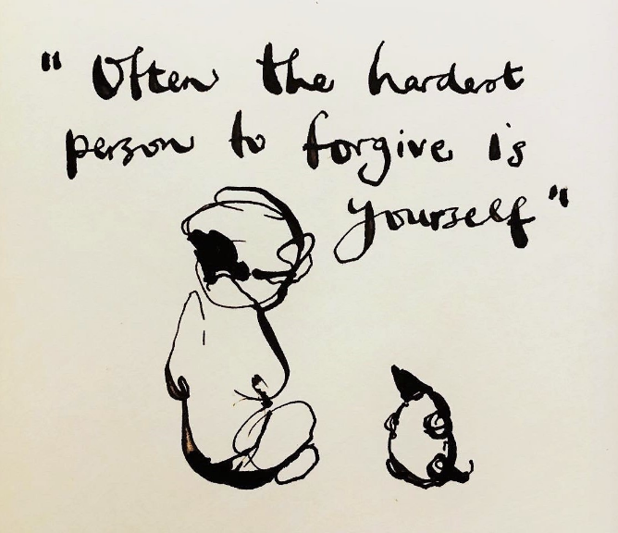

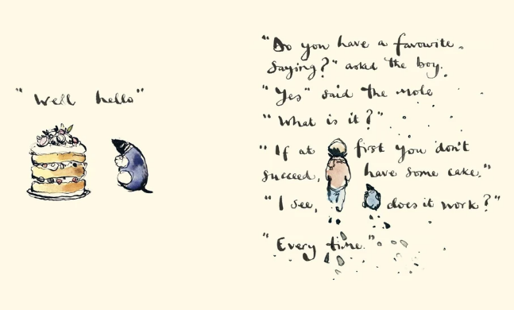

Activity 4

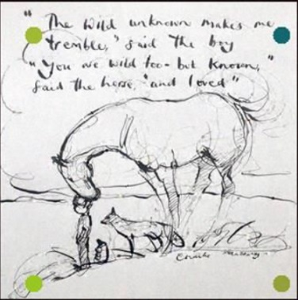

Charlie Mackesy Art

Warm up:
Continuous line drawing
You will need: pen, paper, a small object (such as keys, cutlery, feathers, coins)
- Make a drawing without taking your pen off the paper. Your eye should follow details and contours on the object you are drawing, and your hand should draw these details at the same time. To draw some detail in the middle of the object, your pen should stay on the page, travelling to the bit of paper that you want to draw on.
- Try to make your drawing without taking your eye away from the object you are drawing. Sometimes it can help to use a cardboard square whit a hole in it, slotted over your pen or pencil, which will stop you from being able to see your drawing as you make it.
Art Challenge:
Below are 3 different art lessons to watch and attempt. They get increasingly challenging so choose the one that most appeals to you.

- You Tube felt tip challenge click on this link and try to draw the storm clouds. If you enjoyed this, you could choose a different picture from the book to have a go at.

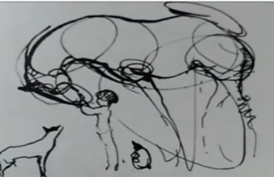
- Charlie Mackesy style horse challenge click on this link to try and draw a Charlie Mackesy style horse.
- Draw with Charlie Mackesy The Royal Albert Hall challenge click on this link to try and draw along with Charlie.

