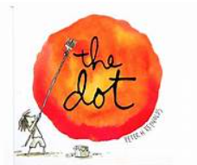
Amazing Art

The Dot
This week’s art session in based on the story “The Dot” by Peter H Reynolds.

Please listen to the story by clicking on the link below:
https://youtu.be/Clpw7PG7m1Q

We are asking all the children in our school to use either the plain dot sheet or the dot sheet in a frame to create their own “dot” picture (scroll down and print the one you would like to work on). You can use any art resources, pencils, paint, felt tips, collage materials to create your very own picture based around the black dot.
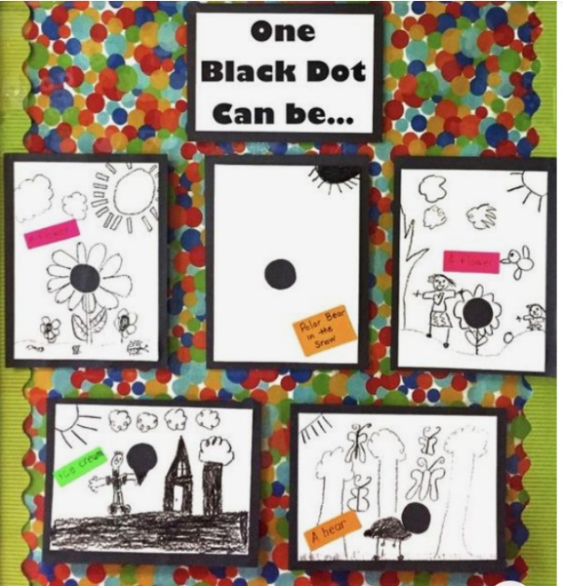

Here are some examples of children who just used black felt tip but you can use whatever art materials you like.

We will be asking you to show your dot pictures in your Friday afternoon zoom meeting and would also love it if you could share it on the blog. We can then create a whole school remote learning gallery!



