Smell | Touch | Sight | Sound
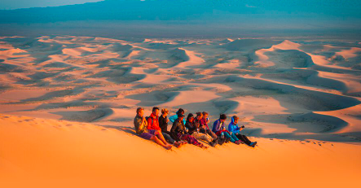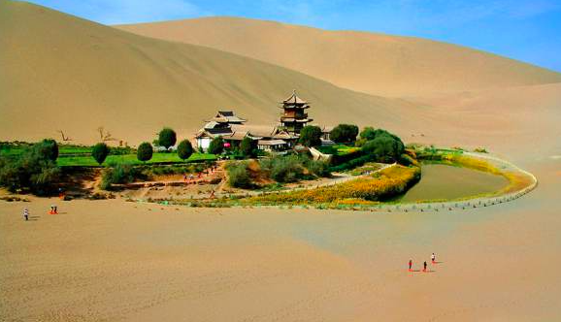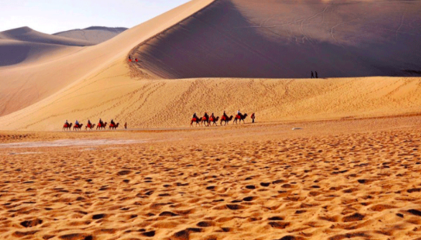
Look at the three pictures of the Gobi Desert.
Write a list of words to describe what you would smell, feel, see and hear.

