Thursday and Friday
In class we have been revising adding and subtracting 2 2-digit numbers.
These videos explain our methods:
https://vimeo.com/468518962
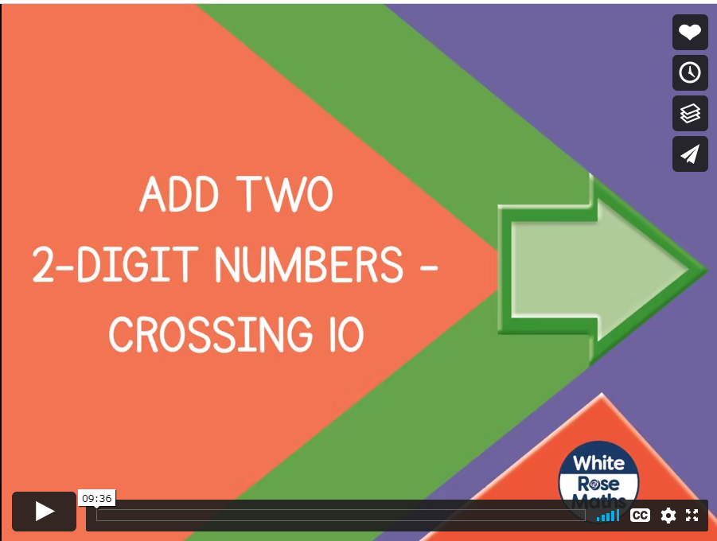

https://vimeo.com/468562834
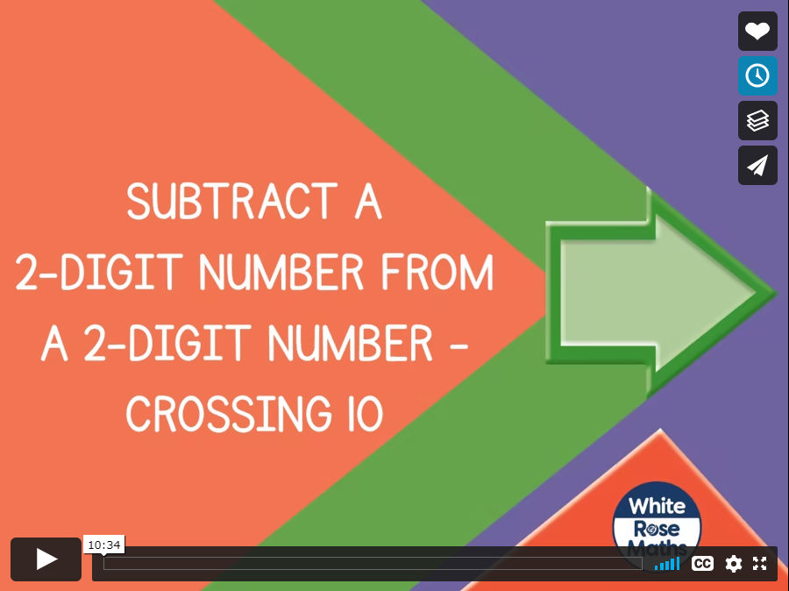

Watch the videos and then complete the worksheets. There is also a problem solving task to complete to see if addition and subtraction skills learnt can be applied to word problems.

Art
This week the children are drawing pansies. You can adapt this to draw any flower in your garden. I would like you to draw it three ways:
- Using a pencil, carefully observe the flower and then draw what you see.
- Using watercolours/paints, observer the same flower, draw it and colour match the colours you see using paints.
- Using paper/collage, observe the same flower and recreate it using small bits of paper. Try to use complete pieces for each petal etc rather than lots of little bits all cut up.
I would love to see what you create!

