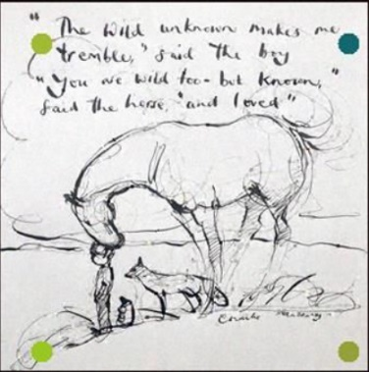

Charlie Mackesy Art

Warm up:
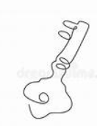
Continuous line drawing
You will need: pen, paper, a small object (such as keys, cutlery, feathers, coins)
- Make a drawing without taking your pen off the paper. Your eye should follow details and contours on the object you are drawing, and your hand should draw these details at the same time. To draw some detail in the middle of the object, your pen should stay on the page, travelling to the bit of paper that you want to draw on.
- Try to make your drawing without taking your eye away from the object you are drawing. Sometimes it can help to use a cardboard square whit a hole in it, slotted over your pen or pencil, which will stop you from being able to see your drawing as you make it.
Art Challenge:
Below are 3 different art lessons to watch an attempt. They get increasingly challenging so choose the one that most appeals to you.
- You Tube felt tip challenge click on this link and try to draw the storm clouds. If you enjoyed this, you could choose a different picture from the book to have a go at.
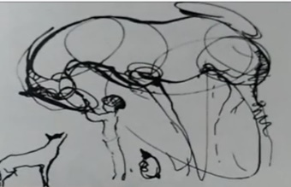
- Charlie Mackesy style horse challenge click on this link to try and draw a Charlie Mackesy style horse.
- Draw with Charlie Mackesy The Royal Albert Hall challenge click on this link to try and draw along with Charlie.

