Marvellous Maths (w/c 1.3.21)
Brain boost: Year 2
This a problem solving activity that can be done on any day.

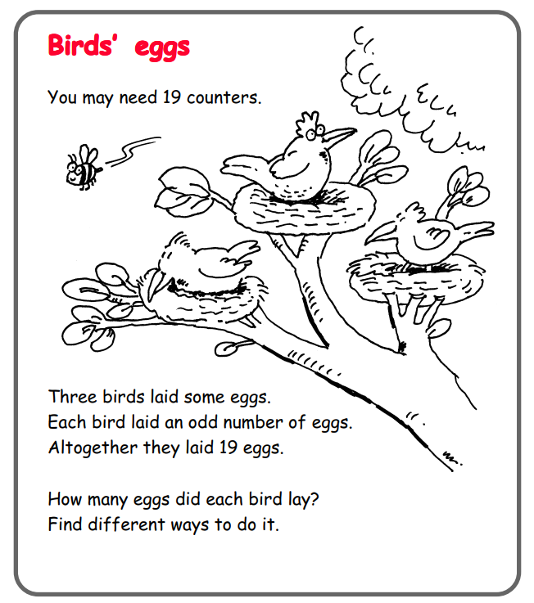

In addition to the lessons below, your child needs to continue to practise times tables. They can do this using their TT Rockstars account or through other games, by making flash cards etc.
The children all have Numbots accounts too. This is to develop their fluency in maths and although the games start off being quite simple, it will get increasingly challenging for them.
We suggest 10 minute sessions on both per day.
Year 2
Friday
Today your child will be using the multiplication symbol.
Please click on the following link:
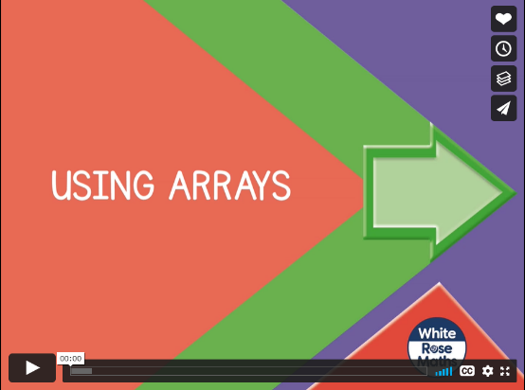
https://vimeo.com/490417143
Stop the lesson where it suggests and complete the activities on the sheet “Use arrays” in the resources.
As with last week’s tasks, it is useful if your child has some small objects such as counters, pasta, cereal etc to help them.

For the rest of today’s learning, I would like your child to focus on the 2, 5 and 10 times tables. They can do this by completing the maths sheets on the resources or playing one of the games below (or they can do the sheets and the games if they are keen!).
https://www.topmarks.co.uk/maths-games/hit-the-button
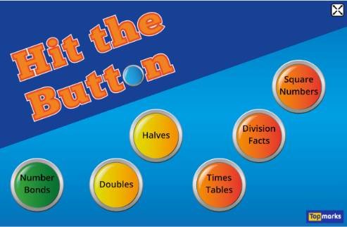

https://www.topmarks.co.uk/maths-games/mental-maths-train


