Marvellous Maths (w/c 1.3.21)
Brain boost: Year 3
This a problem solving activity that can be done on any day.

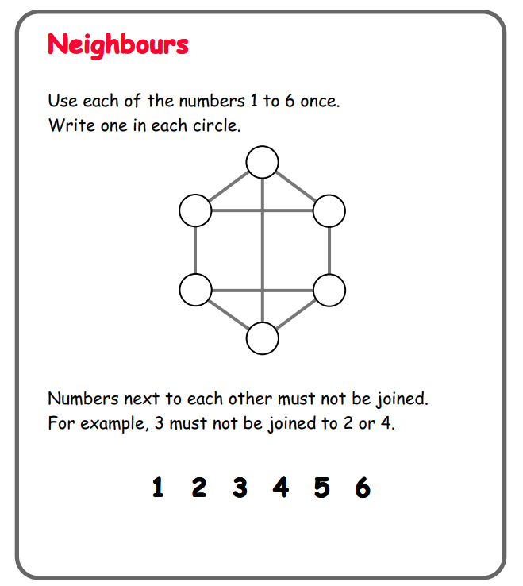

In addition to the above, your child needs to continue to practise times tables. They can do this using their TT Rockstars account or through other games, by making flash cards etc.
The children all have Numbots accounts too. This is to develop their fluency in maths and although the games start off being quite simple, it will get increasingly challenging for them.
We suggest 10 minute sessions on both per day.

Year 3
Friday
Please click on the following link:
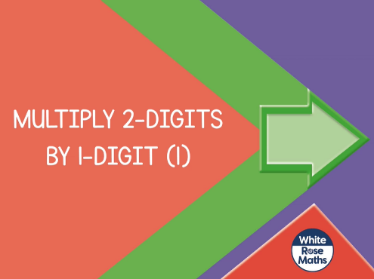
https://vimeo.com/486513593

The lesson will ask your child to pause and complete questions from the “Multiply 2-digits by 1-digit” follow up task in the resources.

Now click on the following link:
https://vimeo.com/489850121
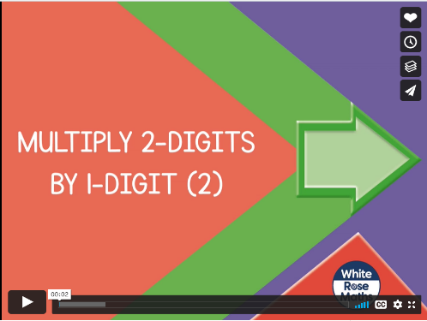
The lesson will ask your child to pause and complete questions from the “Multiply 2-digits by 1-digit part 2” follow up task in the resources.

If your child would like more practice with short multiplication then I have added “optional multiplication practice” to the resources.
If your child would like a challenge, I have added a “multiplication challenge” sheet to the resources.

