Marvellous Maths (w/c 22.2.21)
Brain boost: Year 2
This a problem solving activity that can be done on any day.

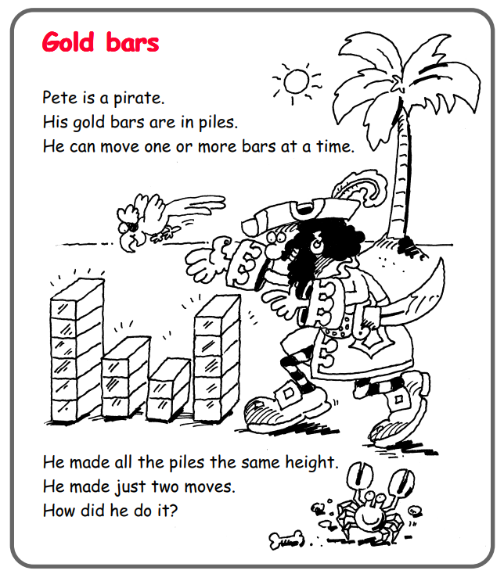

In addition to the lessons below, your child needs to continue to practise times tables. They can do this using their TT Rockstars account or through other games, by making flash cards etc.
The children all have Numbots accounts too. This is to develop their fluency in maths and although the games start off being quite simple, it will get increasingly challenging for them.
We suggest 10 minute sessions on both per day.

Year 2
Thursday
For the next couple of weeks we will be looking at multiplication and division. For today, we will be looking at making and adding equal groups. Please ask your child to watch the following lesson:
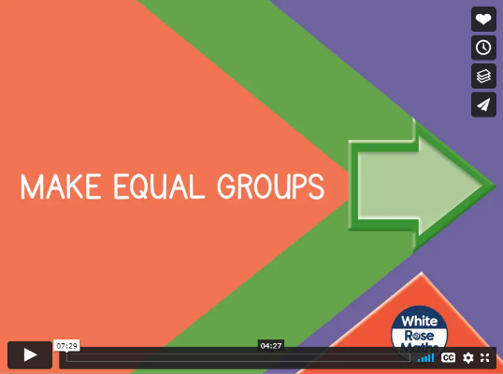
https://vimeo.com/488108584

Now ask your child to complete the “Make Equal Groups” follow up task. It might be useful for them to have some small objects like pasta or cheerios to help them with their tasks.
Please now click on the link below:
https://vimeo.com/488110327
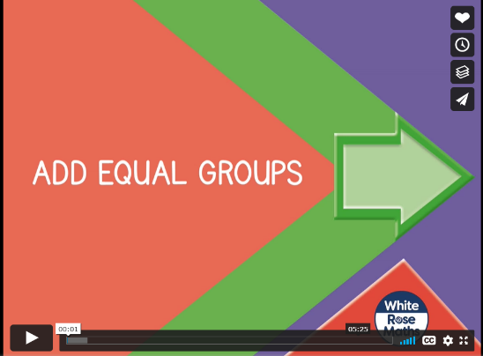

Ask your child to complete the “Add Equal Groups” follow up task. As before, they might find using small objects helpful when completing this.

Friday
Today your child will be using the multiplication symbol.
Please click on the following link:
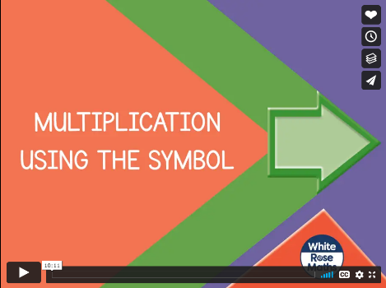
https://vimeo.com/488111269
Stop the lesson where it suggests and complete the activities on the sheet “Using the x symbol” in the resources.
As with yesterday’s tasks, it is useful if your child has some small objects such as counters, pasta, cereal etc to help them see what is happening when they are multiplying amounts.

Now ask them to watch the next lesson:
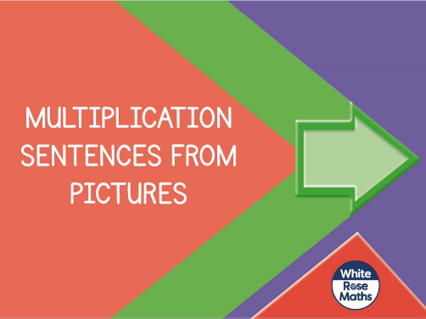
https://vimeo.com/488113679
Please pause the lesson, where suggested, so that your child can complete the relevant questions on the “Multiplication sentences from pictures” task.

If your child would like to practise mental recall of their times tables, they can click on the game below. There are lots of different combinations they can choose from under the “Times Tables” button:
https://www.topmarks.co.uk/maths-games/hit-the-button


