Marvellous Maths (w/c 22.2.21)
Brain boost: Year 3
This a problem solving activity that can be done on any day.

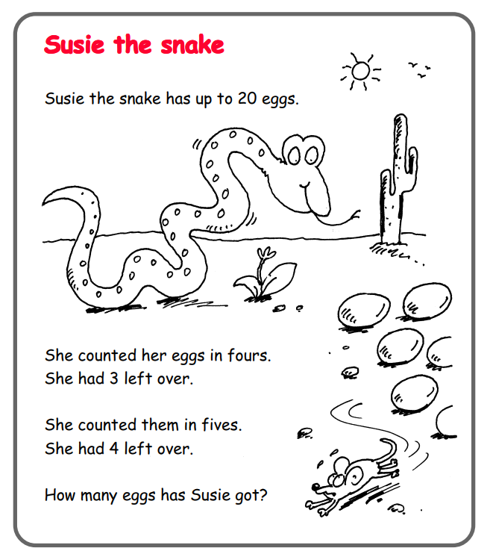

In addition to the above, your child needs to continue to practise times tables. They can do this using their TT Rockstars account or through other games, by making flash cards etc.
The children all have Numbots accounts too. This is to develop their fluency in maths and although the games start off being quite simple, it will get increasingly challenging for them.
We suggest 10 minute sessions on both per day.

Year 3
Thursday
For the next few weeks we will be continuing our learning about multiplication and division. Today we will start with a revision lesson.
Please click on the following link:
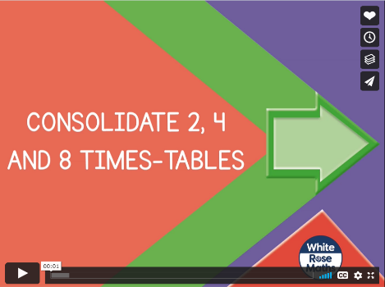
https://vimeo.com/485432791
Pause the lesson, where prompted and ask your child to complete the corresponding questions from the “Consolidate 2, 4 and 8 times tables” task.
If your child would like to play times tables game on the computer, they can use the following link to “Maths Race” and select the times table they wish to practice:
https://mathsframe.co.uk/en/resources/resource/584/Maths-Race-Multiplication
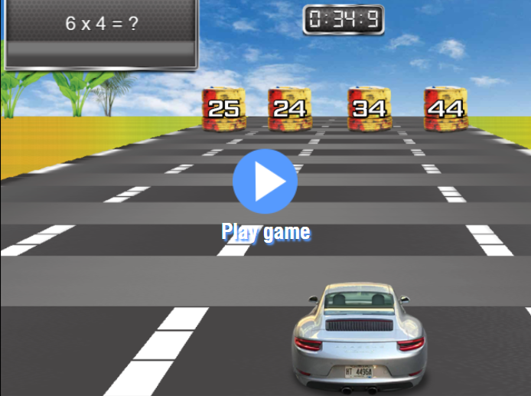
Please now click on the link below and watch the lesson:
https://vimeo.com/485433674
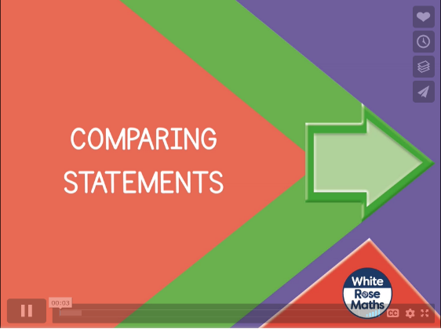
Please ask your child to complete the “Comparing Statements” activity by pausing when suggested in the lesson.
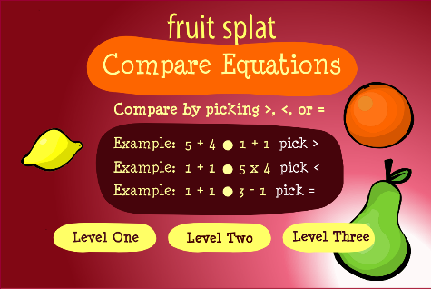
If your child would like to continue to compare mathematical statements, click on the link below to play the game.
https://www.sheppardsoftware.com/math/mixed-operations/compare-equations/

Friday
Please click on the following link:
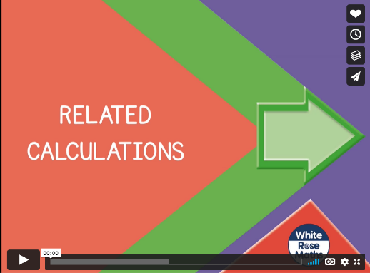
https://vimeo.com/486330232

The lesson will ask your child to pause and complete questions from the “Related Calculations” follow up task in the resources.

Now click on the following link:
https://vimeo.com/486331580
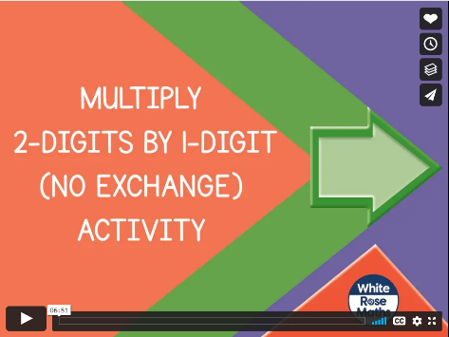
Pause the lesson when prompted and ask your child to solve the problem that the video asks.

If your child would like to practice their times tables I have added a dice game and some colour by multiplication sheets to the resources. Both of these are optional extras.

