Purple Mash cave painting
Today we are going to use some art software on Purple Mash. First click on the link below:
https://www.purplemash.com/sch/buriton

To log in the username is Year3 and the password is also Year3 (case sensitive, no space)
From the home screen, click on Topics
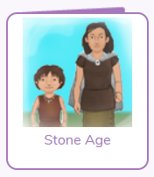
And then scroll down to until you find the Stone Age icon:

You now need to click on the Stone Age Art slideshow to look at some examples of cave paintings:
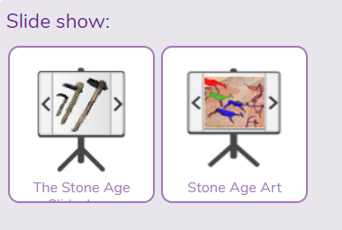
After watching the slideshow, have a go at your own using the paint tool. Click on the “Cave Painting” icon in the Painting section.

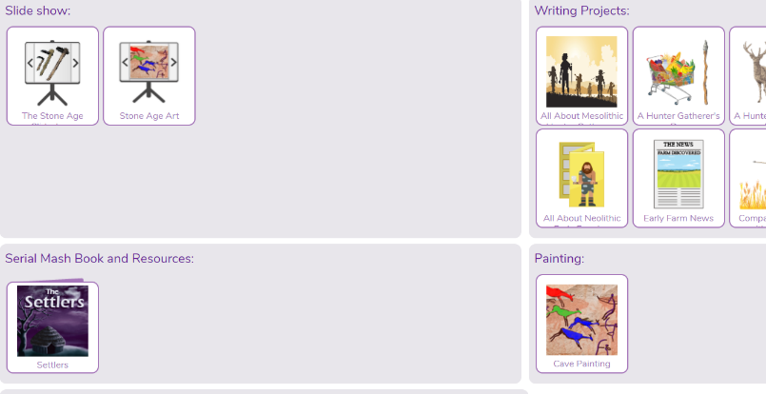

Now you will be able to use the paint program to create your own cave painting. Just to recap:
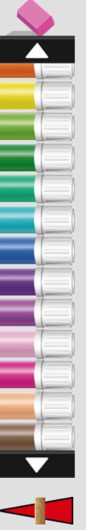
Click on the arrows to scroll through the colour options.

Slide this bar to change the thickness of your pen.


Remember if you make a mistake use the pink rubber at the top of the pens or click on the backwards arrow.

If you can, please print your cave picture ready to bring into school.

Good luck!

