Marvellous Maths (w/c 8.2.21)
Brain boost: Year 2
This a problem solving activity that can be done on any day.

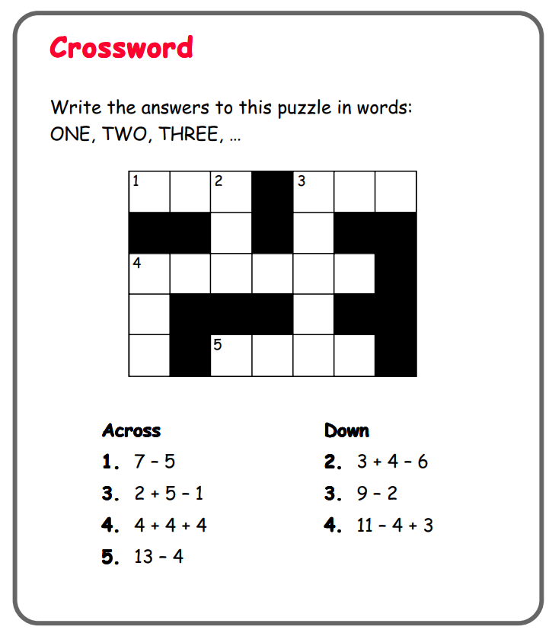

In addition to the lessons below, your child needs to continue to practise times tables. They can do this using their TT Rockstars account or through other games, by making flash cards etc.
The children all have Numbots accounts too. This is to develop their fluency in maths and although the games start off being quite simple, it will get increasingly challenging for them.
We suggest 10 minute sessions on both per day.

Year 2
Thursday
Today your child is continuing to learn how to draw and interpret pictograms.
Your child will be asked to complete question 1 on the “Draw Pictograms” early on in this lesson and they will need to pause where suggested and the answers will be discussed as the video continues. Please click on the following link:
https://vimeo.com/504483835
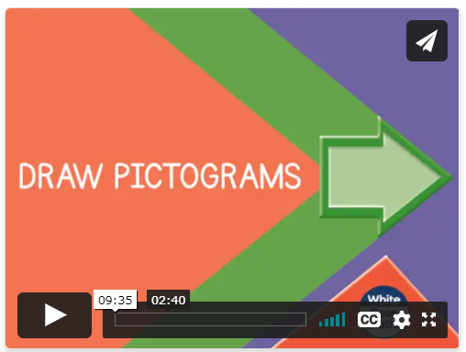
Follow up task:
Ask your child to complete the “Draw Pictograms” and then move on to the lesson below:
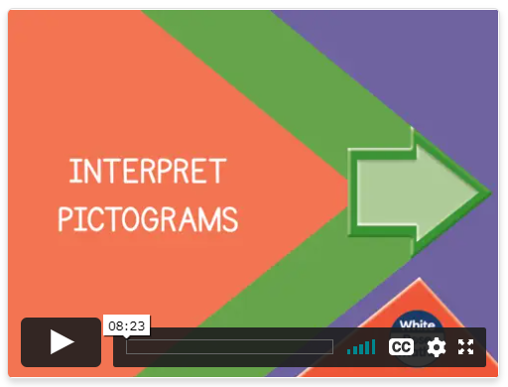
https://vimeo.com/504484570

Ask you child to complete the “Interpret Pictograms” activity in the resources.

Friday
Today your child will learn how to construct and interpret a simple block diagram.
Please click on the following link:
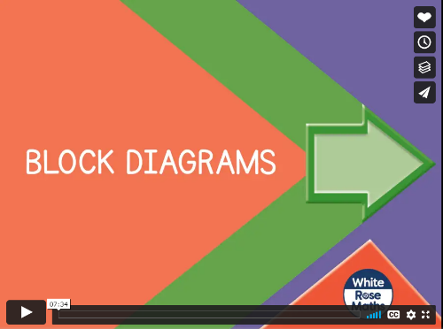
https://vimeo.com/504485413

Stop the lesson where it suggests and complete the activities on the sheet “Block Diagrams” in the resources.
There is a blank block diagram template if your child would like to draw their own block diagram using data they collected from last week, or new data that they wish to use.
If your child likes accessing maths games on the computer, they can click on the following link to play bar chart game:
https://mathsframe.co.uk/en/resources/resource/51/bar_charts


