Marvellous Maths (w/c 8.2.21)
Brain boost: Year 3
This a problem solving activity that can be done on any day.

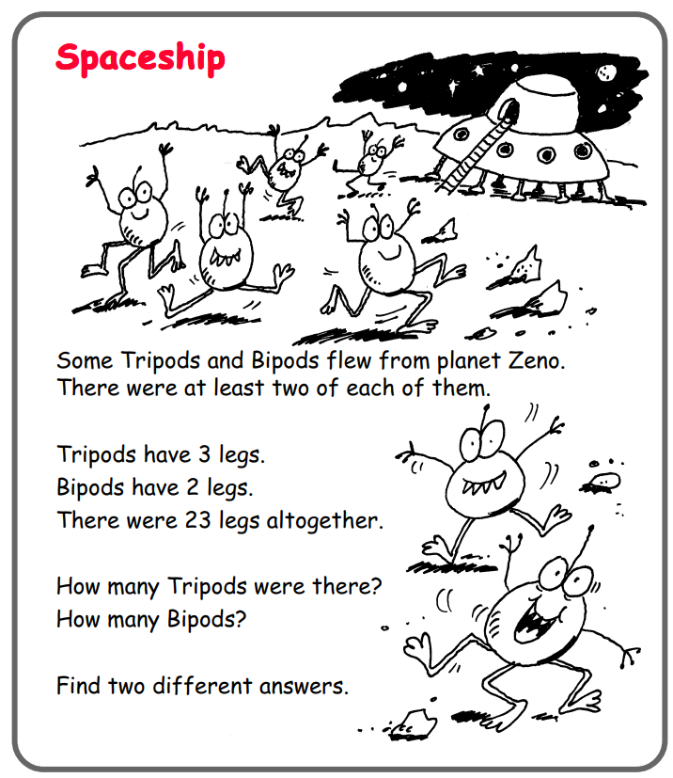

In addition to the above, your child needs to continue to practise times tables. They can do this using their TT Rockstars account or through other games, by making flash cards etc.
The children all have Numbots accounts too. This is to develop their fluency in maths and although the games start off being quite simple, it will get increasingly challenging for them.
We suggest 10 minute sessions on both per day.

Year 3
Thursday
Today your child is learning how to draw bar charts.
Please click on the following link:

https://vimeo.com/501677687

Follow up task:
During this lesson, your child will be asked to complete their own bar chart using data provided. There is a template on the website to help them if they do not want to draw their own grids (“bar char template”). They then need to have a go and the dice activity where they generate their own data and then put it into a bar chart. They can use the “Dice data record chart” to record their rolls and the bar chart template to make their chart.
If your child would like to play a bar chart game on the computer, they can use the following link:
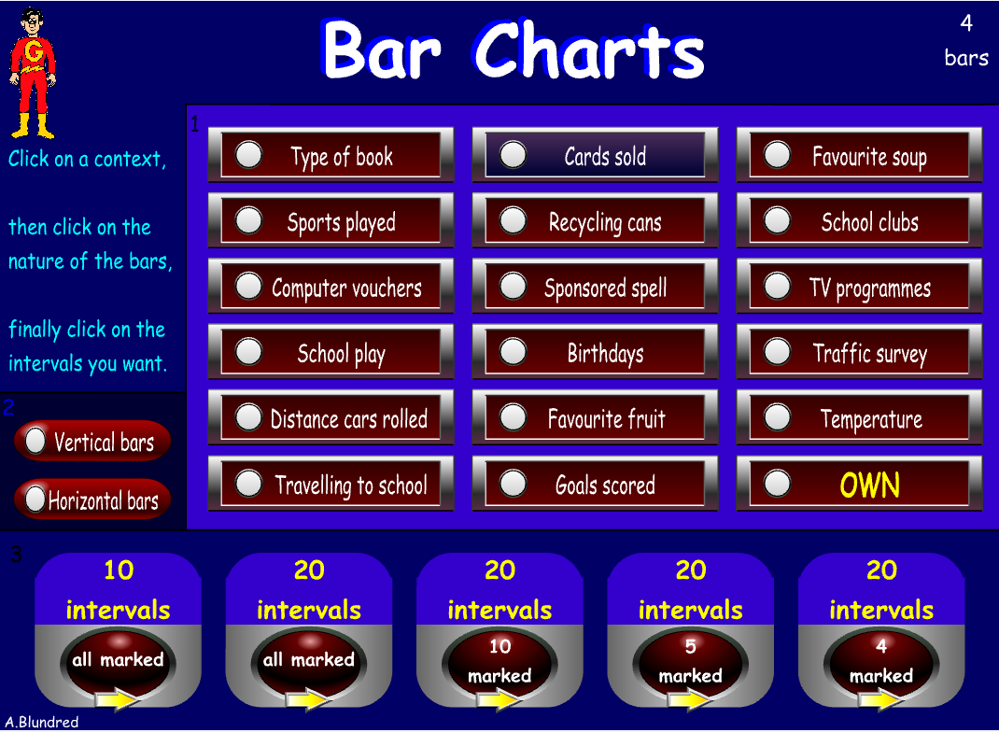
https://www.topmarks.co.uk/Flash.aspx?f=barchartv2

This can be adapted to make it as challenging as they want.

Friday
Today your child will learn how to draw and interpret data using bar chart and tables.
Please click on the following link:
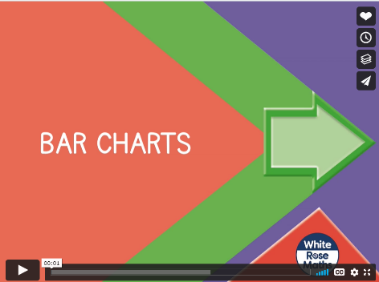
https://vimeo.com/502337848

Ask your child to complete the “Bar charts” follow up task on the resources.

Now click on the following link:
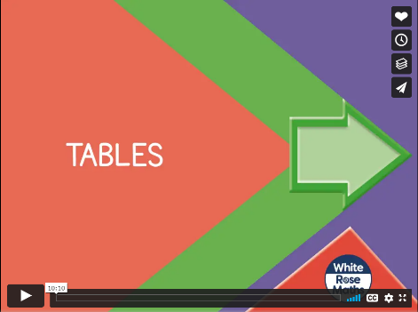
https://vimeo.com/502338566

Please ask your child to complete the “Tables” activity on the website.

