2Code Bubbles
Today we are going to use 2Code to learn how to write instructions to make the computer perform certain tasks. We are also going to learn how debug programs so that they work correctly.
First click on the link below:
https://www.purplemash.com/sch/buriton
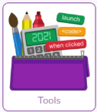
To log in the username is Year3 and the password is also Year3 (case sensitive, no space)
From the home screen, click on Tools

And then scroll down to Coding and click on 2Code
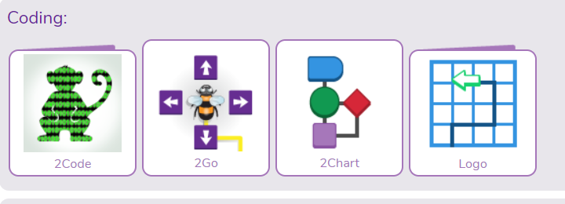

You now need to click on Bubbles:
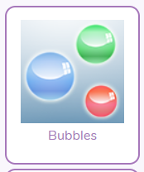
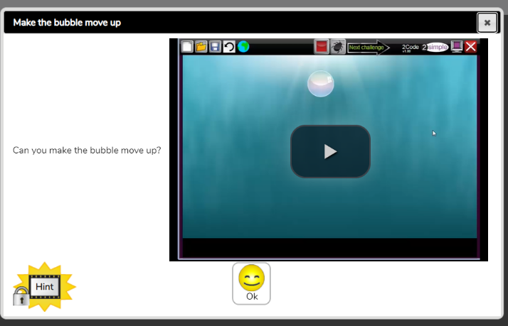
You will be given a set of 4 challenges. Try and work out how to complete each one on your own, using what we learned last week. If you get stuck click on the “Hints” box and this should help you.

At the end of your 4 challenges you can create your own bubbles animation. Have a play with the coding and see if you can make your bubbles:
Change direction
Make a sound
Make more than one disappear at once

Good luck!

