Marvellous Maths (w/c 1.2.21)
Brain boost: Year 2
This a problem solving activity that can be done on any day.

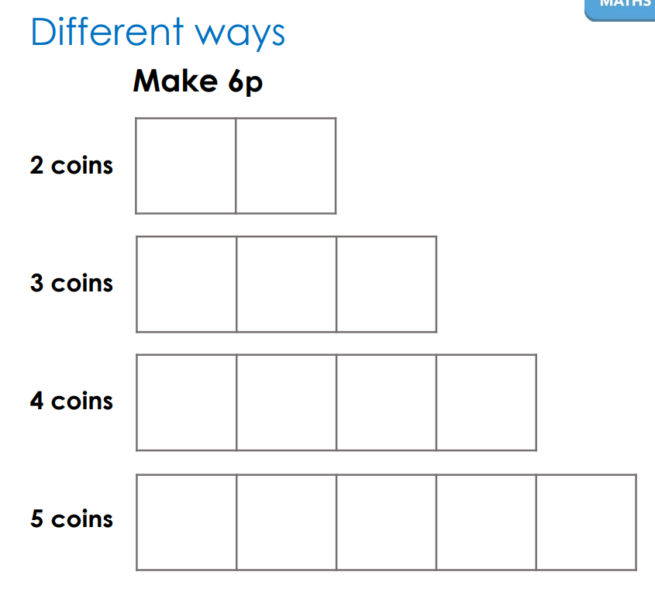
In addition to the lessons below, your child needs to continue to practise times tables. They can do this using their TT Rockstars account or through other games, by making flash cards etc.
The children all have Numbots accounts too. This is to develop their fluency in maths and although the games start off being quite simple, it will get increasingly challenging for them.
We suggest 10 minute sessions on both per day.

Year 2
Thursday
Today your child is learning how to interpret and construct tally charts.
Please click on the following link:
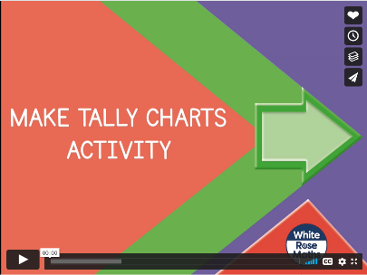
https://vimeo.com/501669795
Follow up task:
Ask your child to construct a tally chart using their own data. They can use categories such as favourite colours and ask family, imagine what their toys would say or use objects like a pack of jelly babies or skittles. They could also use the bird data collected for the Bird watch challenge over the weekend. The template for the tally chart is in the resources.

Now ask your child to watch the lesson below:

https://vimeo.com/501671369

Print the corresponding sheet “Make tally charts” and ask your child to pause and complete the questions when prompted in this lesson.
If your child needs more of a challenge, I have added a tally problem solving sheet to the resources.

Friday
Today your child will learn how to construct a simple pictogram.
Please click on the following link:
https://vimeo.com/501672753
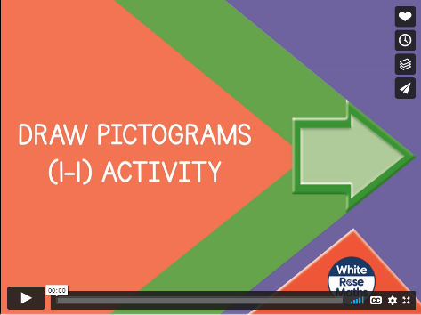
Stop the lesson where it suggests and go for a walk. Ask your child to think of 3 or 4 things they might repeatedly see on their walk e.g. dogs, people, cars, bikes. Before you set out, your child needs to decide what picture they will use as their “key”. They also need to draw their table. Once this has been done, go on the walk and ask your child to complete their table to show what they have seen. Alternatively, your child could look for certain shapes, colours, food around the house and make a pictogram using this data.

If your child likes accessing maths games on the computer, they can click on the following link to play a pictogram game:
http://toytheater.com/fishing/


