Marvellous Maths (w/c 1.2.21)
Brain boost: Year 3
This a problem solving activity that can be done on any day.

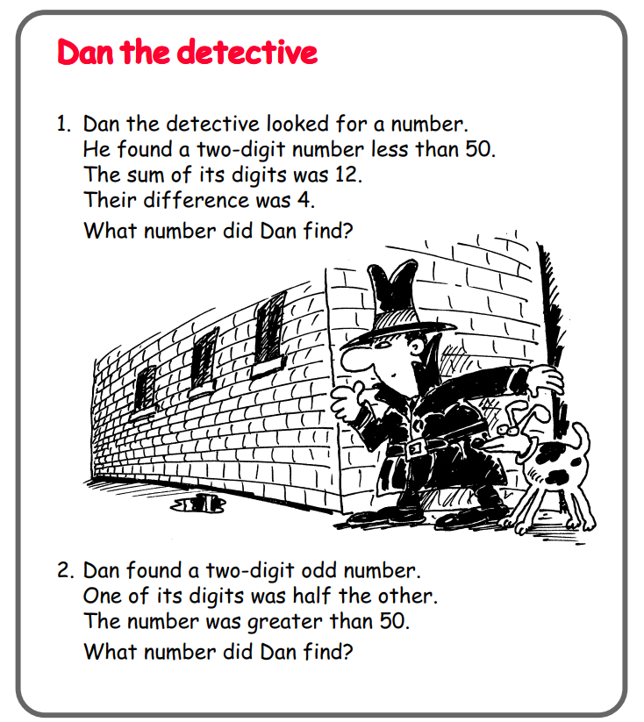

In addition to the above, your child needs to continue to practise times tables. They can do this using their TT Rockstars account or through other games, by making flash cards etc.
The children all have Numbots accounts too. This is to develop their fluency in maths and although the games start off being quite simple, it will get increasingly challenging for them.
We suggest 10 minute sessions on both per day.

Year 3
Thursday
Today your child is learning how to interpret and construct tally charts.
Please click on the following link:

https://vimeo.com/501669795

Follow up task:
Ask your child to construct a tally chart using their own data. They can use categories such as favourite colours and ask family, imagine what their toys would say or use objects like a pack of jelly babies or skittles. They could also use the data they collected if they did the Bird Watch at the weekend. The template for the tally chart is in the resources.

Click on the link and watch the video:

https://vimeo.com/500377891

Print the corresponding sheet “Make tally charts” and ask your child to pause and complete the questions when prompted in this lesson.
If your child needs more of a challenge, I have added a tally problem solving sheet to the resources.

Friday
Today your child will learn how to present and interpret data using a pictogram.
Please click on the following link:
https://vimeo.com/500379996


Ask your child to make their own pictogram based on the date they collected yesterday. They can use the “pictogram template” on the resources if they wish or draw their own table.
If they would like to do more, I have attached the worksheets that follow this lesson but this is optional.

Now click on the following link:

https://vimeo.com/500378019

Please ask your child to complete the “Interpreting pictograms” activity on the website.

