2Code
Today we are going to use 2Code to learn how to write instructions to make the computer perform certain tasks.
First click on the link below:
https://www.purplemash.com/sch/buriton
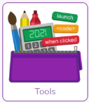
To log in the username is Year3 and the password is also Year3 (case sensitive, no space)
From the home screen, click on Tools

And then scroll down to Coding and click on 2Code
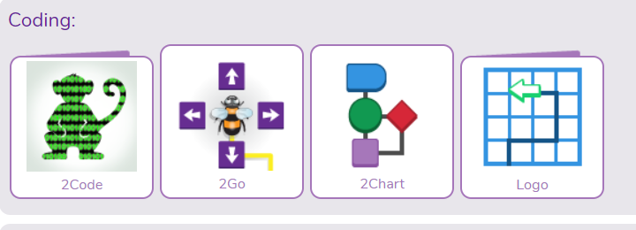

Next you need to click on 2Code Video Tutorials and then Quick Start. Listen and watch the quick start tutorial.
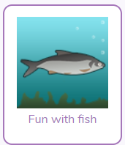
Your screen should look like this:
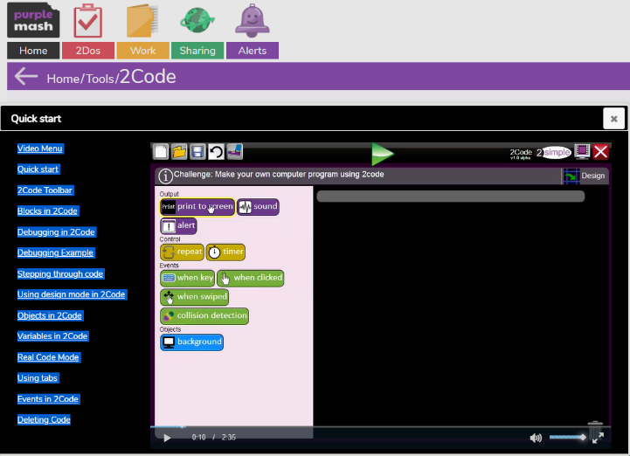
When you have watched the tutorial video, click the little white cross at the top of the screen and then click on “Fun with Fish”.

This will open a programme that asks you to complete some coding (challenge 1 and 2), then fix the program (3) and then make your own fish program (challenge 4).
- Move the tuna right. Click on this challenge first. To start the challenge you must first click on the smiley face that says ok. Then drag the word tuna into the grey box. Direction arrows will appear for you to choose the word “right)
.
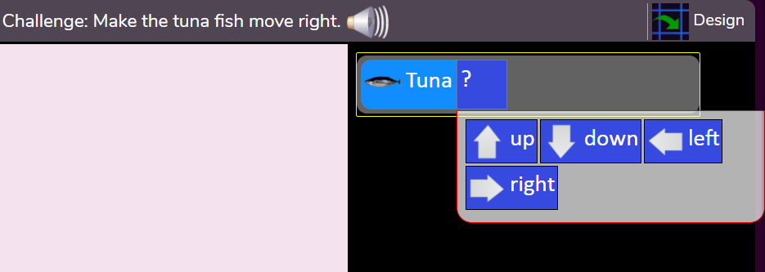
Then click on the green play triangle at the top of the screen. If you have completed this correctly you will be able to move onto challenge 2 by clicking the “Next Challenge” arrow:
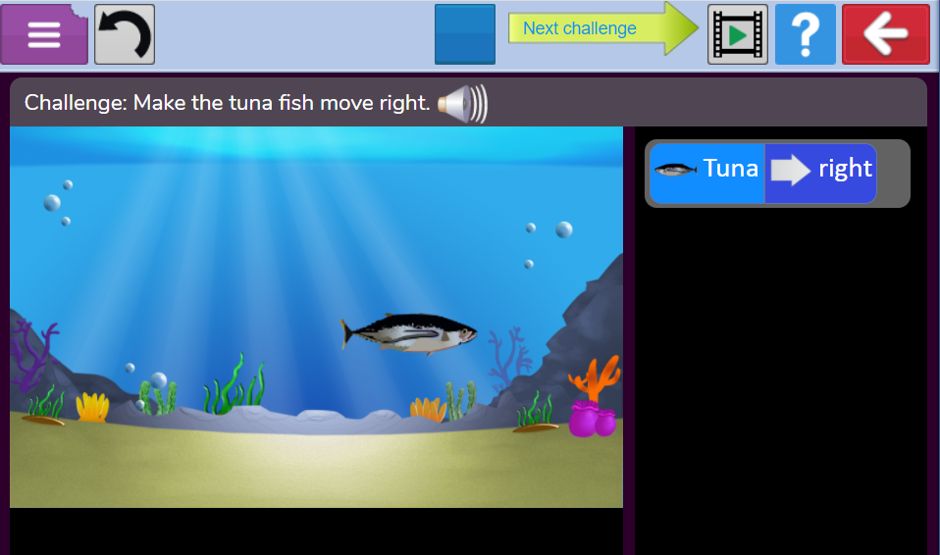
The next challenge is to move the crab left.
- As before, start with clicking the ok smiley face. Drag the word crab under the word tuna. The direction list will appear and this time you will need the left arrow. Once selected, click on the green play triangle. If you have completed the correct coding you will be have the next challenge arrow appear.
- Click on the Info button before you click on the smiley ok face. This will tell you the problem you will need to fix. For each fish, click on the direction and a new list will pop up. Choose the correct direction from this list. You will need to do this for every fish. When you have completed this, you will need to click on the smiley faces to get to challenge 4.
- First click on the “design” square:

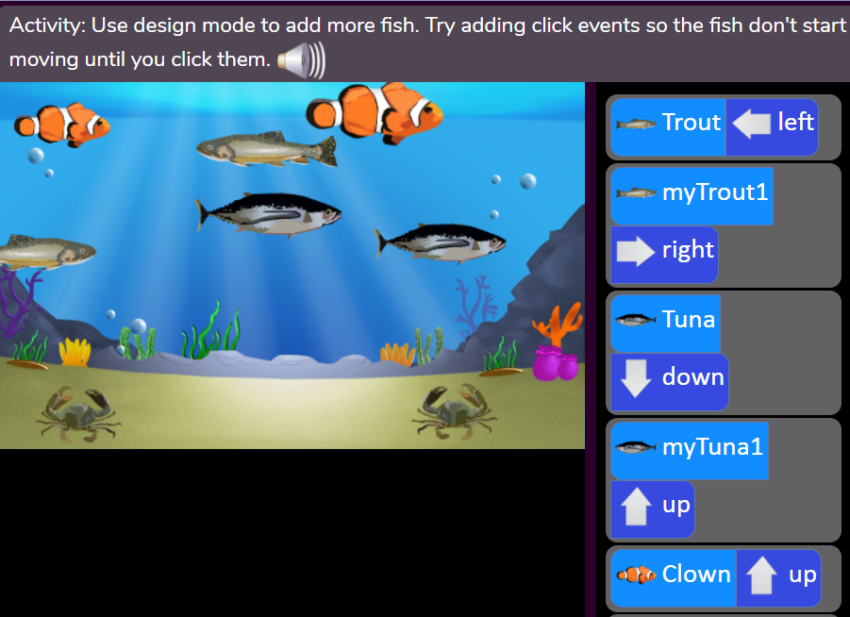
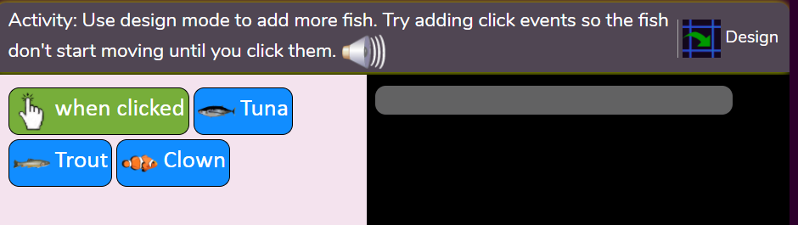
Now you will be able to drag as many fish and crabs as you want onto your sea background. When you have enough, click on the exit design and you will be able to set codes for each of the fish.

You can play and stop your programme by clicking the green triangle/blue square at the top of the picture.

Explore what happens when you add “when clicked” into your list of commands!

Good luck!

