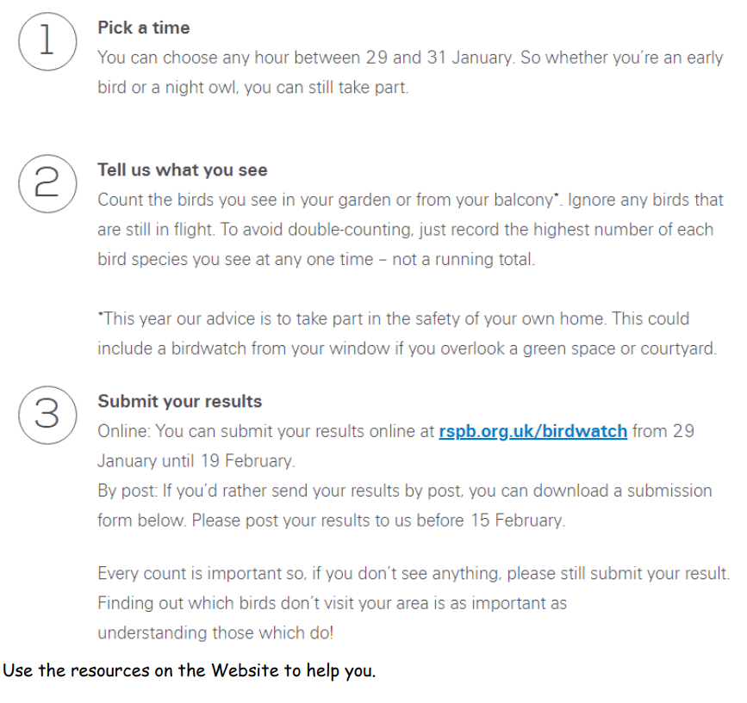
This week we would really like you to take part in the “birdwatch”. Here’s what you have to do:

