Marvellous Maths (w/c 25.1.21)
Brain boost: Year 2
This a problem solving activity that can be done on any day.

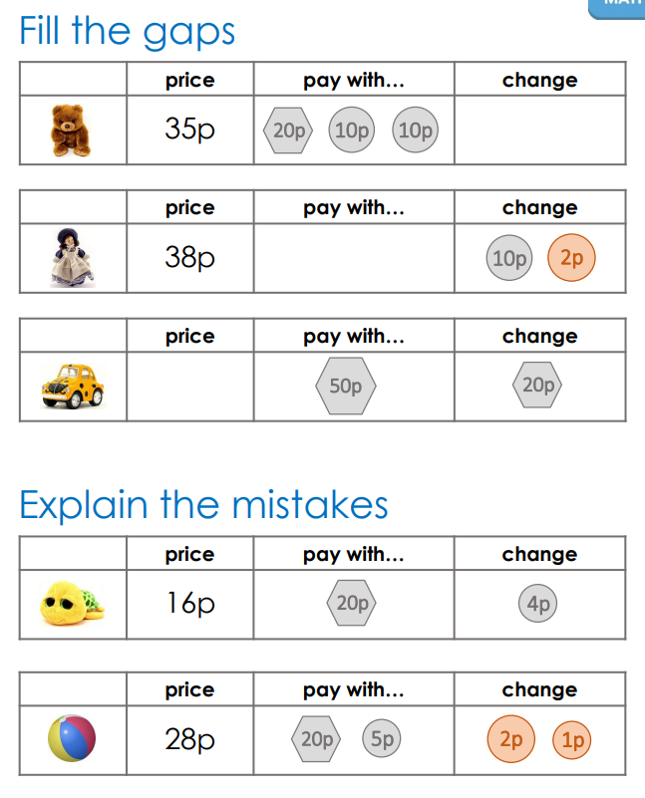

Year 2
This week your child is learning to find the difference between amounts of money and then calculate change. Before they calculate change, we will look at some subtraction strategies.
Thursday
Please click on the following link:
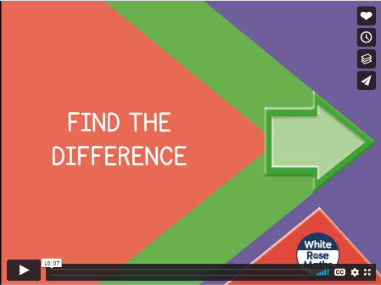
https://vimeo.com/479816379

Stop the video where it tells you to pause and complete the suggested numbered questions in the “Find the difference" follow up task in the resources.

Now we are going to focus on subtraction strategies. Start by watching this video.
https://vimeo.com/468561808
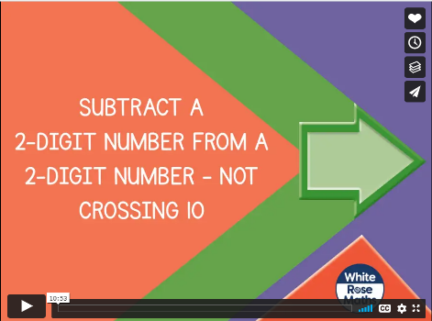
This lesson introduces your child to column subtraction.
As with the first lesson, pause the video and complete the “Subtract 2 digit numbers part 1” questions when prompted.

Friday
Today we will continue to practise the column method of subtraction before moving on to finding change.
Please click on the following link:
https://vimeo.com/468562834
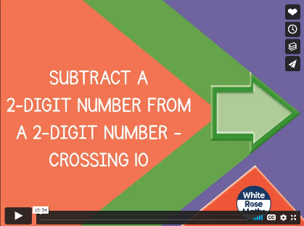
As with yesterday, pause the video when asked and complete the appropriate questions on the follow up task “Subtract a 2 digit number part 2” from the website.

Now the children can apply what they know about subtraction to finding change with money. Click on the following link:
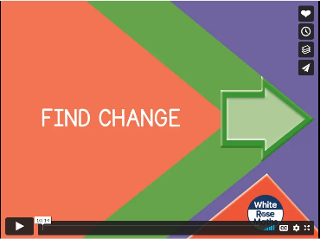
https://vimeo.com/479816820
Pause the video when asked and complete the appropriate questions on the follow up task “Find change” from the website.

Other options:
If your child has found giving change tricky (or wants to do more), I have attached some extra activities that might be easier:
Y2 Giving change at the toy shop (these sheets have 3 levels of difficulty)
Alternatively, they can click on the following link:
https://www.topmarks.co.uk/money/toy-shop-money
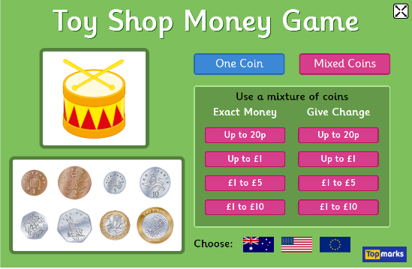
This game also allows your child to practice giving change at different levels of difficulty.

If your child is finding change difficult, it often helps to make this concept practical by setting up a role play shop and using real money and objects.

In addition to the above, your child needs to continue to practise times tables. They can do this using their TT Rockstars account or through other games, by making flash cards etc.
The children all have Numbots accounts too. This is to develop their fluency in maths and although the games start off being quite simple, it will get increasingly challenging for them.
We suggest 10 minute sessions on both per day.

