Marvellous Maths (w/c 25.1.21)
Brain boost: Year 3
This a problem solving activity that can be done on any day.

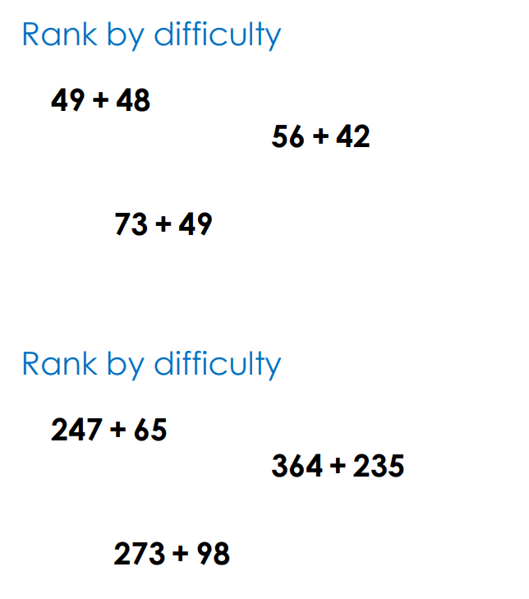

Year 3
Thursday
The focus for your child today is to learn subtraction strategies.
Please click on the following link:

https://vimeo.com/463955357

Your child will need to pause this video when prompted and complete the appropriate questions from the follow on task “Subtract 2 digit numbers”.

Click on the link and watch the video:
https://vimeo.com/465481885

Once again your child will need to pause the video when prompted to complete the appropriate questions form the follow on task “subtract a 2 digit number from a 3 digit number”.

Friday
Today we will apply the subtraction strategies to money.
Please click on the following link:
https://vimeo.com/498297373

Your child will need to pause this video when prompted and complete the appropriate questions from the follow on task “Subtract money”.

Now click on the following link:
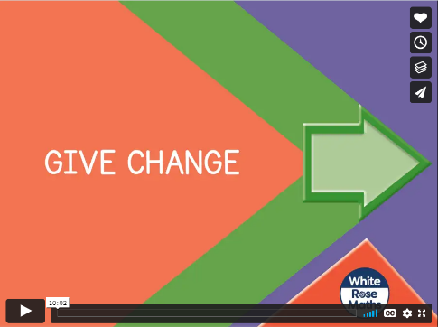
https://vimeo.com/499227948

Your child will need to pause this video when prompted and complete the appropriate questions from the follow on task “Give change”.

Other options:
If your child is finding giving change difficult they could try the following worksheets:
Checking change from £1, checking change from £5 or checking change from £10 (all on the website)
Alternatively, they might like to click on the following link and play the toy shop game:
https://www.topmarks.co.uk/money/toy-shop-money

This game also allows your child to practice giving change at different levels of difficulty.

If your child is finding change difficult, it often helps to make this concept practical by setting up a role play shop and using real money and objects.

In addition to the above, your child needs to continue to practise times tables. They can do this using their TT Rockstars account or through other games, by making flash cards etc.
The children all have Numbots accounts too. This is to develop their fluency in maths and although the games start off being quite simple, it will get increasingly challenging for them.
We suggest 10 minute sessions on both per day.

