Marvellous Maths
Brain boost: Year 2
This a problem solving activity that can be done on any day.

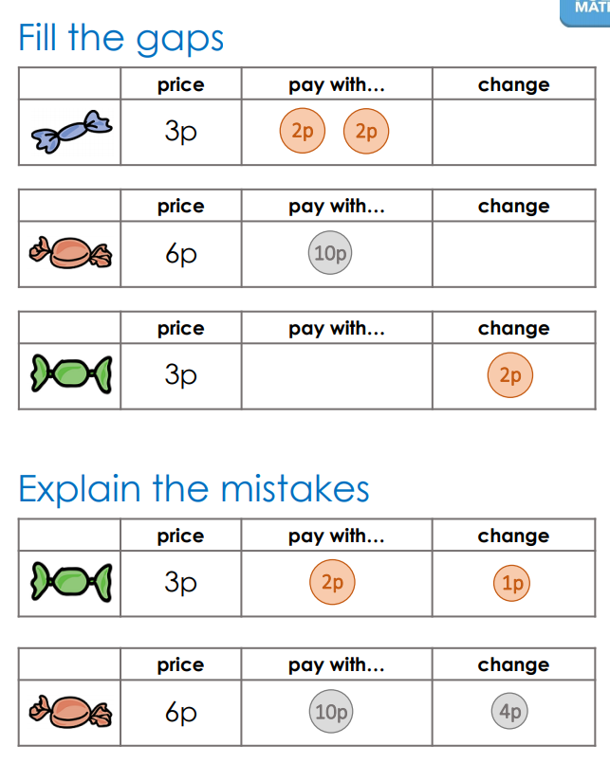

Year 2
This week your child is learning to add money. To start with they will compare money and then we will move on to addition methods before returning to adding money together.
Thursday
Please click on the following link:
https://whiterosemaths.com/homelearning/year-2/week-11-measurement-money/
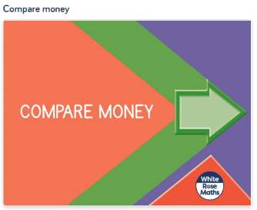
Now complete the “compare money” follow up task in the resources.

Now we are going to focus on addition strategies. Start by watching this video.
https://vimeo.com/467781234
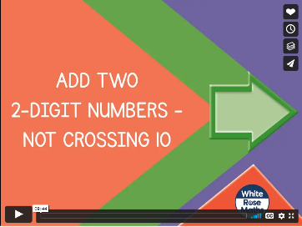
This lesson introduces your child to column addition.
The follow task is in the resources and called “adding 2 digit numbers part 1”.

Friday
Today we will continue to practise the column method of addition before applying it to adding money.
Please click on the following link:
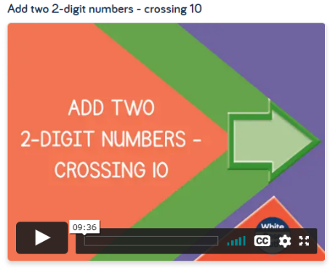
https://whiterosemaths.com/homelearning/year-2/week-8-number-addition-subtraction/

Please ask your child to watch the video and then complete the follow up task called “Adding 2 digit numbers part 2”.

Now please click on the following link and watch the video “Find the Total”:
https://whiterosemaths.com/homelearning/year-2/week-11-measurement-money/
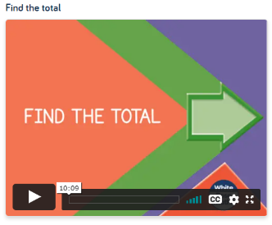
After watching the video, ask your child to complete the follow up task called “Find the Total” in resources.

In addition to the above, your child needs to continue to practise times tables. They can do this using their TT Rockstars account or through other games, by making flash cards etc.
The children all have Numbots accounts too. This is to develop their fluency in maths and although the games start off being quite simple, it will get increasingly challenging for them.
We suggest 10 minute sessions on both per day.

