Marvellous Maths
Brain boost: Year 3
This a problem solving activity that can be done on any day.

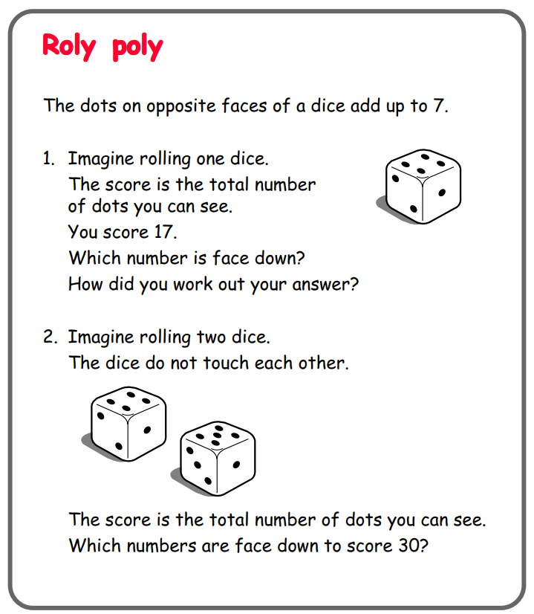

Year 3
Thursday
The focus for your child today is to convert pounds and pence. There is also a revision lesson about addition that will help them when they come to adding money.
Please click on the following link:
https://vimeo.com/497942634

Now as your child to complete the “Convert pounds and pence” task on the website.
There is also and extension exercise “Convert pounds to pence” if your child is finding the first task easy.

Click on the link and watch the video:
https://vimeo.com/463954202
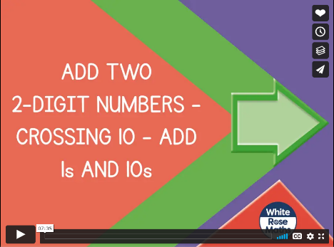
Now ask your child to complete the follow up task “Add 2 digit numbers” on the website.

Friday
Today we will continue with addition strategies before moving on to adding money.
Please click on the following link:
https://vimeo.com/464967055
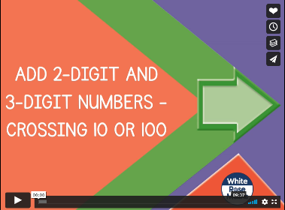
Now ask your child to complete the “Add 2 and 3 digits” follow up task.

Now click on the following link:
https://vimeo.com/498286318

After this video, please ask your child to complete the “Add Money” follow up task on the website.

In addition to the above, your child needs to continue to practise times tables. They can do this using their TT Rockstars account or through other games, by making flash cards etc.
The children all have Numbots accounts too. This is to develop their fluency in maths and although the games start off being quite simple, it will get increasingly challenging for them.
We suggest 10 minute sessions on both per day.

