Marvellous Maths
Brain boost: Year 2
This a problem solving activity that can be done on any day.

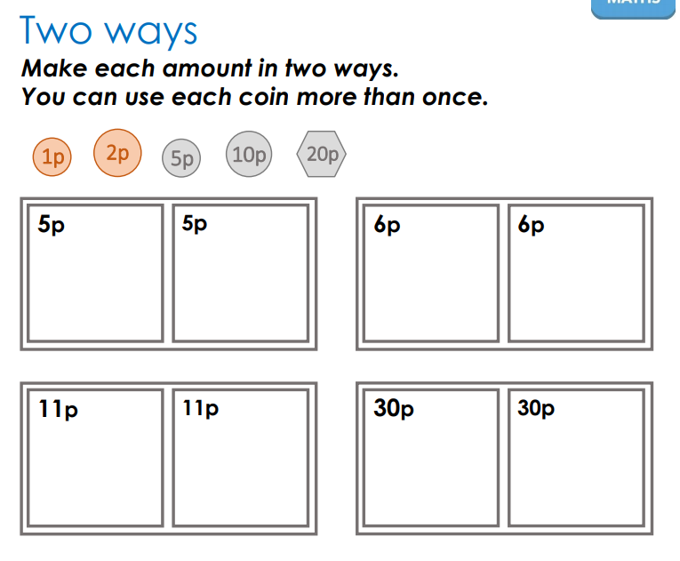
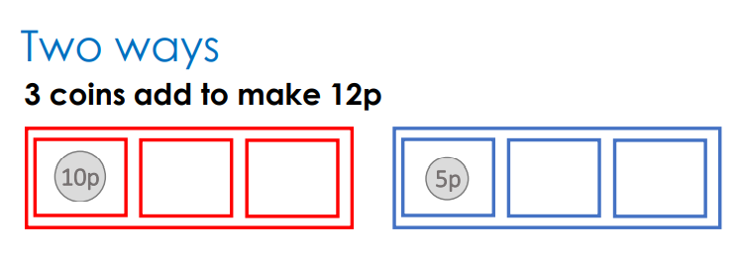

Year 2
Thursday
The focus for your child today is to count money in pence, in pounds and in a mix of pounds and pence.
Please click on the following link:
https://whiterosemaths.com/homelearning/year-2/week-10-measurement-money/
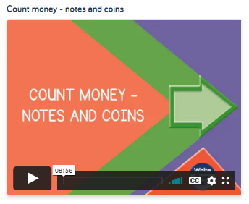
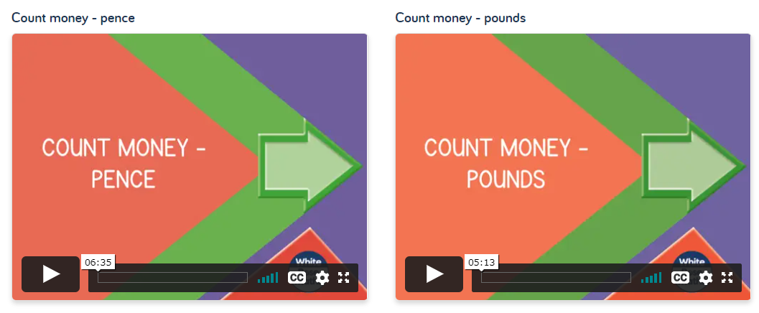
Please ask your child start with the lesson counting in pence. There are then some follow up tasks for this lesson on the class website, called Year 2 Thursday follow up tasks, that should be completed before watching “count money – pounds.” Again there are follow up tasks that should be completed before watching “Count money – notes and coins”.
Follow up tasks:
The resources on the website have tasks to complete after each of these three lessons. After count money in pence lesson, please ask your child to complete the activities with the heading “count money-pence”. After the second lesson they should complete the sheets headed “Count money in pounds” and then after the third lesson complete the activities headed “Count money notes and coins”.

Friday
The focus for today is for your child to be able to select coins to make a particular value and to find different combinations of coins that equal the same value.
Please click on the following link:
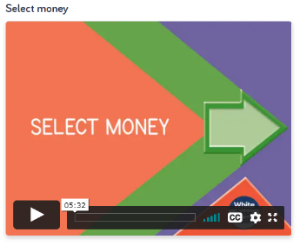
https://whiterosemaths.com/homelearning/year-2/week-10-measurement-money/
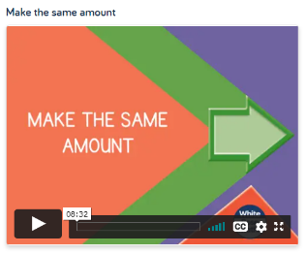

Please ask your child to watch the video “Select money” and then they need to complete the tasks in the resources section before moving on to the lesson “Make the same amount”.
Follow-up task:
Please ask your child to complete the tasks under the heading “Select Money” from the website. They are called “Year 2 Friday follow up tasks”. After watching the second lesson, please ask your child to complete the follow up tasks called “Make the same amount.”

In addition to the above, your child needs to continue to practise times tables. They can do this using their TT Rockstars account or through other games, by making flash cards etc.
The children all have Numbots accounts too. This is to develop their fluency in maths and although the games start off being quite simple, it will get increasingly challenging for them.
We suggest 10 minute sessions on both per day.

