Marvellous Maths
Brain boost: Year 3
This a problem solving activity that can be done on any day.

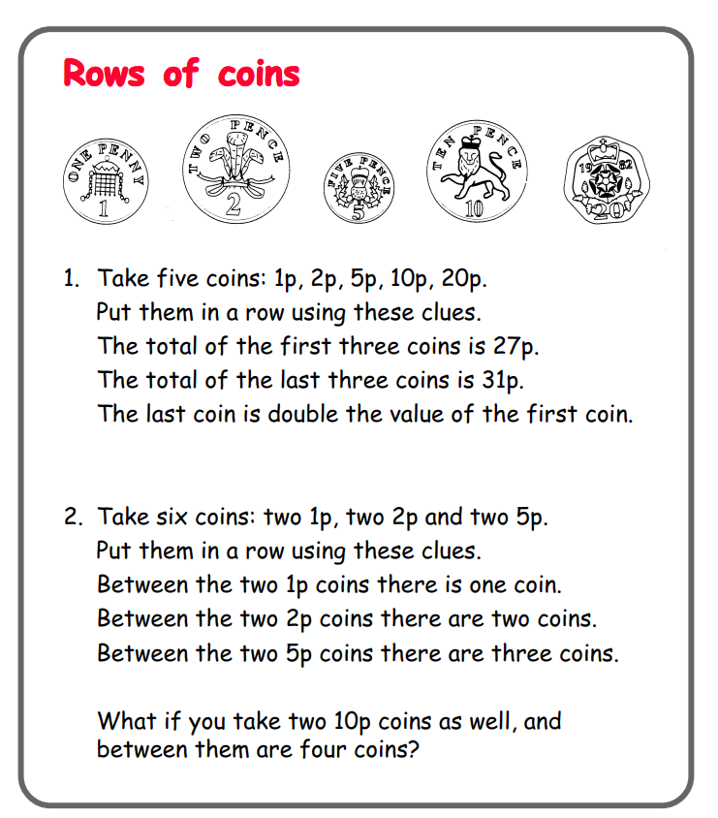

Year 3
Thursday
The focus for your child today is to measure the perimeter of 2D shapes.
Please click on the following link:
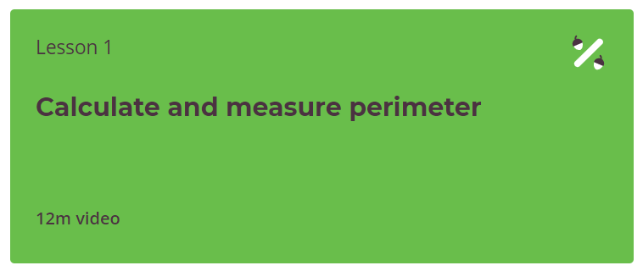
https://classroom.thenational.academy/units/2-d-shape-perimeter-and-area-9929

Follow up tasks:
Complete the “Measure the perimeter of 2D shapes” task on the website. You could also draw your own shapes and then measure their perimeter.

Friday
The focus for today is for your child to be revise counting money before moving on to adding and subtracting amounts of money to give change next week.
Please click on the following link:
https://vimeo.com/497343674



Please ask your child to watch the video “Count Money” (pence) and then they need to complete the Count Money (pence) follow up task in the resources section before moving on to the lesson “Count money” (pounds) below:
https://vimeo.com/497344241
Follow-up task:
Please ask your child to watch the video and complete the tasks “Count money pounds follow up task” in the resources.
Finally ask your child to watch this video:
https://vimeo.com/497345587
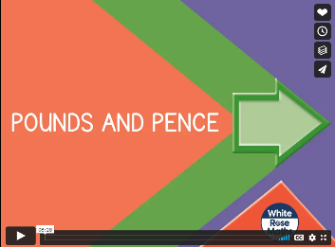
The final follow up task can be found in the resources and is called “Pounds and pence follow up task”.

In addition to the above, your child needs to continue to practise times tables. They can do this using their TT Rockstars account or through other games, by making flash cards etc.
The children all have Numbots accounts too. This is to develop their fluency in maths and although the games start off being quite simple, it will get increasingly challenging for them.
We suggest 10 minute sessions on both per day.

