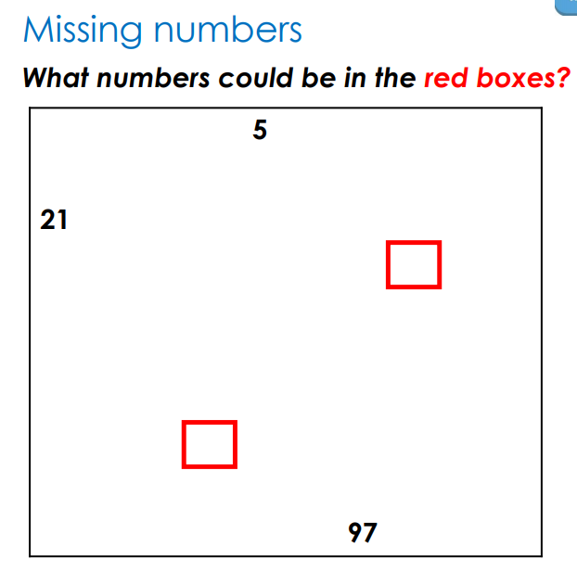
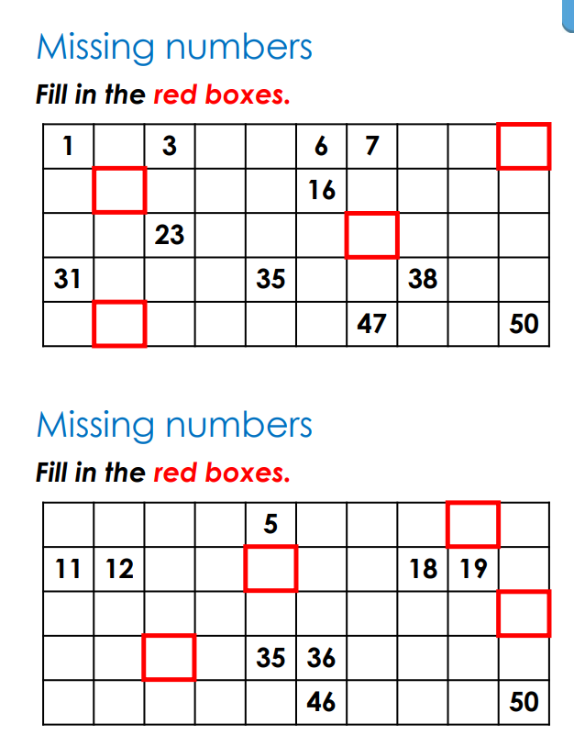
Marvellous Maths
Brain boost: Year 2
This a problem solving activity that can be done on any day.

Year 2
Thursday
The focus for today is for your child to be able to count forwards and backwards in steps of 2 and 5 from 0.
Please click on the following link:
https://whiterosemaths.com/homelearning/year-2/week-4/
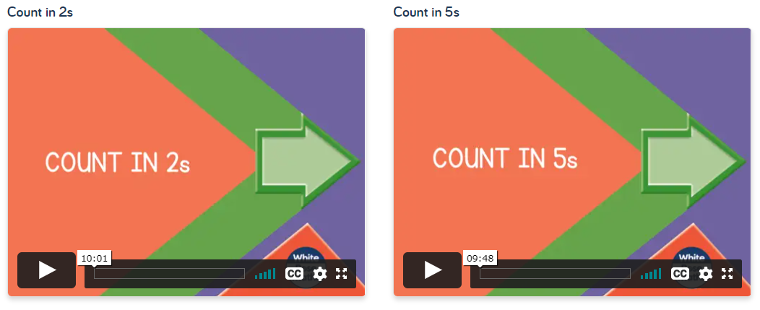
Please ask your child start with the counting in 2s lesson and then to focus on the counting in 5s lesson (counting in 2s should be revision). Do not be put off by the fact this directs you to week 4 of the Autumn Term. The children are not behind! The maths teaching sequence is different for each scheme and we will hop around a bit.
Follow up task:
Please complete the counting in 2s and the counting in 5s sheet in the maths resources section. There are different ability sheets so please choose the one that is most suitable for your child.

Friday
The focus for today is for your child to be able to count forwards and backwards in steps of 10 from any number. They will also be reading and writing numbers to 100 in words.
Please click on the following link:
https://whiterosemaths.com/homelearning/year-2/week-4/
Please ask your child focus on the counting in 10s lesson.
Follow-up task:
Please complete the counting in 10s lily pads. There are a range of different counting steps so scroll through until you find the counting forward and then counting backwards in 10s. If your child is keen, they can do the other lily pad sheets too!
Then click on the following link:
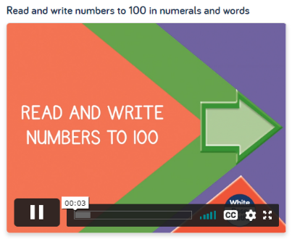
https://whiterosemaths.com/homelearning/year-2/week-2/

Follow up task:
Please ask your child to complete the numbers as words wordsearch and the writing numbers in words task.

In addition to the above, your child needs to continue to practise times tables. They can do this using their TT Rockstars account or through other games, by making flash cards etc.
The children all have Numbots accounts too. This is to develop their fluency in maths and although the games start off being quite simple, it will get increasingly challenging for them.
We suggest 10 minute sessions on both per day.

Brain boost: Year 3
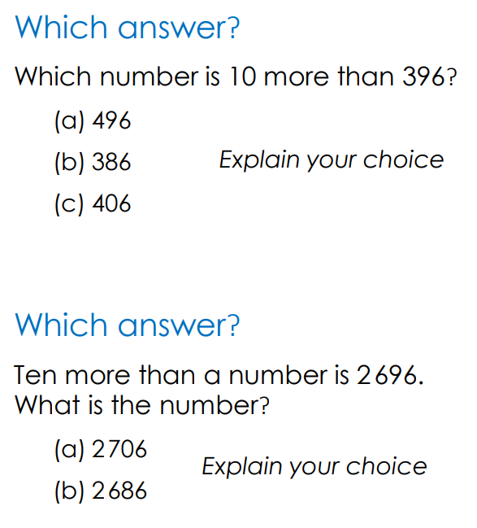
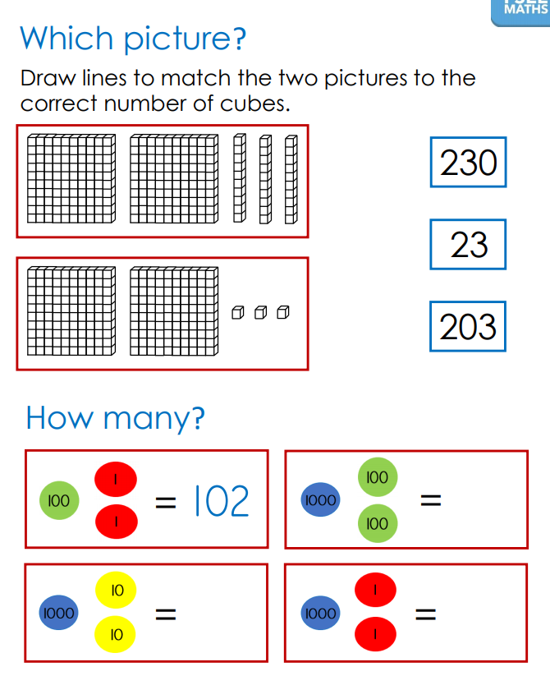
This a problem solving activity that can be done on any day.
Year 3
Thursday
The focus for this lesson is for your child to be able to find 10 or 100 more or less than a given number.
Click on the link below and ask your child to watch the following 2 lessons. These will act as revision. Do not be put off by the fact this directs you to week 2 of the Autumn Term. The children are not behind! The maths teaching sequence is different for each scheme and we will hop around a bit.

https://whiterosemaths.com/homelearning/year-3/week-2/
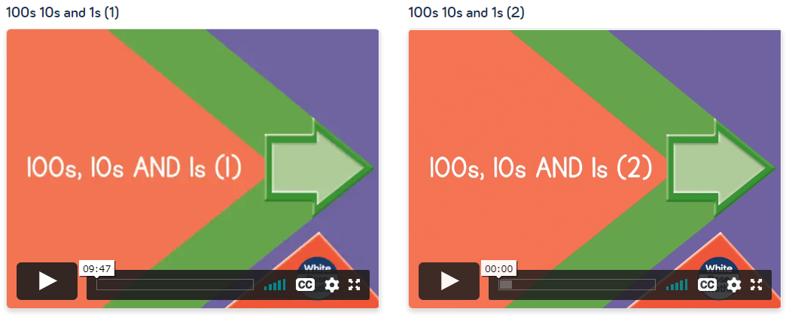


Next watch the lesson below:

Follow up task:
Complete the 10 and 100 more or less activity. There are different levels of challenge so pick the one that suits your child.
Now ask your child to complete the writing numbers in words sheet. There is a word mat on the resources too as support if necessary.

Friday
The focus for this lesson is for your child to count in multiples of 4 and 50.
First look at this lesson by clicking on the link below:
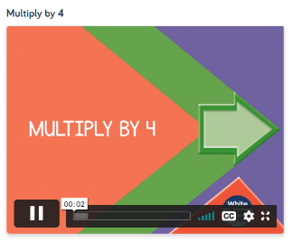
https://whiterosemaths.com/homelearning/year-3/week-11-number-multiplication-division/

Follow up task:
Complete the counting in multiples of 4 activities.

Next look at the count in 50s lesson by clicking on the link below:

https://whiterosemaths.com/homelearning/year-3/week-3/
Follow up task:
Complete the counting in 50s activity sheet.

In addition to the above, your child needs to continue to practise times tables. They can do this using their TT Rockstars account or through other games, by making flash cards etc.
The children all have Numbots accounts too. This is to develop their fluency in maths and although the games start off being quite simple, it will get increasingly challenging for them. This is a good resource if your child struggles to recall number facts or finds mental maths activities quite difficult.
We suggest 10 minute bursts per day.

