WB 8.6.2020 .
Welcome to week 9 of our online home learning journey.
From this week some of our class will be returning to school as Keyworker children along with the Year R, 1 and 6 children and I’m sure we all wish we were there with them.
As Miss Moore and Mrs Pinhorn will be teaching Year 1 Monday – Thursday and Mrs Evans will be teaching them on Fridays it is going to be very difficult to set up a Zoom each week with all of us. Therefore Mrs Evans will be continuing the weekly zoom meetings alone as a class from today (Monday 8th June) at 11 o’clock. Please Email c.evans@buriton.hants.sch.uk if you would like to be included and I will add you to the list.
Miss Moore will no longer have any input into the Sapphires home learning so again if you have any questions please contact me (Mrs Evans).
I am trying to ensure the homelearning is accessible for children both at home and back at school so please, as always, do what you are able to do and supplement your learning with the websites we have signposted in previous weeks.
I hope you enjoyed last week’s activities and have fun completing this week’s.
Have a good week.
With love
Mrs Evans, Miss Moore and Mrs Pinhorn xx

Lovely Literacy
Reading
Year 2 – Make sure you read every day for about 20 mins. This can be anything that interests you or a book you’ve already read.
Complete pages 38-47 of your Year 2 Reading CGP Book – At the Library.
Year 3 – Read every day for about 20 minutes. Talk about what you have read and why people in the text behave the way they do.
If you want to do more use Twinkl to find reading activities for year 3.

Writing Year 2 and 3

This week we are using the book ‘Journey’ by Aaron Becker.

Lesson 1:
Imagine a magical doorway like the one below has appeared in your garden.
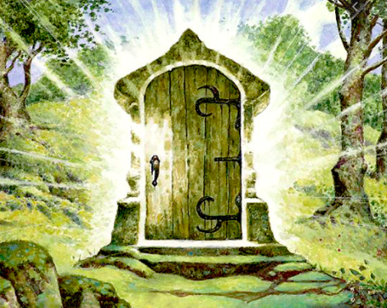

Look at the picture and write down 10 questions you would like to ask about the land behind the door.
Use the question sheet to help you.

Lesson 2:
What do you think you will find behind the door?
Draw and colour a picture of what you imagine the land behind the door to be like.
Write some descriptive words and phrases around your picture.
Use the Fantasy land sheet to complete this work.

Lesson 3:
Look at the front cover of the book.

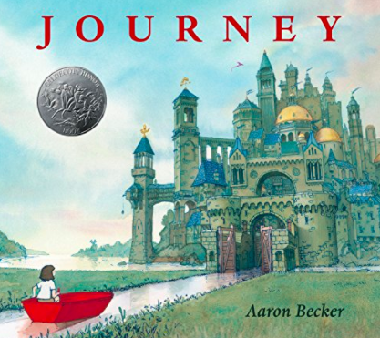
What do you think the story will be about?

Who is the girl in the boat?

What happens to her?

If you have a version of Journey by Aaron Becker (book, e-book, audio book or film) it would be great for your child to read, listen to or watch the book during the week.
Alternatively pop over to the video blog to watch Mrs Evans read it.

We are going to write our own story about a magical ‘portal’ (or doorway) to another world. It will be based on the picture you drew of your own world.

Read my description – below - of the girl approaching the city.

The city loomed large in front of me – dark against the bright blue sky. Some of the roofs of the buildings shone gold in the sun and every one of these was dome shaped. The buildings were so cramped together that I couldn’t imagine how people could move from one to the other without stepping on each other!
As the boat rocked beneath me it stirred up the smells of the river and as we moved closer I began to catch the smell of the ocean. It tasted salty on my tongue and mixed with something like the dust of old buildings.
Although the only real sound I could hear was the lapping of the water against the boat in the distance I could hear voices and heavy footsteps. I began to feel nervous as I neared the gates of the city.

Which senses have I used in my description?
Imagine you are going through the door into your own world.
Can you write a description (like mine) using the senses to describe your entrance.

Remember to use lots of interesting vocabulary.
This will be the beginning of your story.
You can use the transport border story sheet to write this on if you like.

Lesson 4:

Today you are going to write the next part of your story.
In ‘Journey’ the following pictures are used to depict the dangers that she finds in the city and beyond.
. 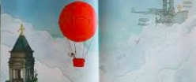
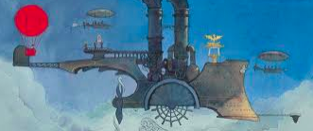
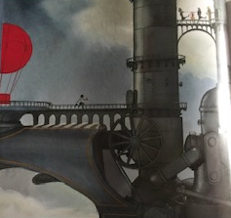
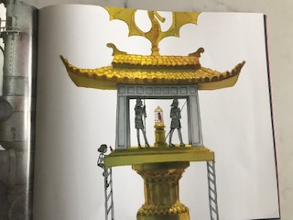
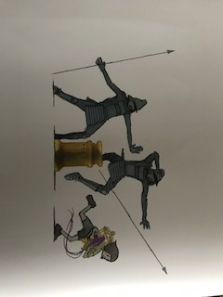

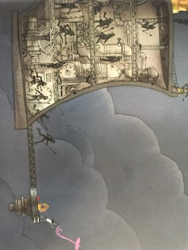
The next part of your story begins with…
When I finally arrived…..
You are going to write about the dangers you find in your new world.
Write down your ideas below in note form before you write the next part of your story on the transport borders.
I have written up the dangers of ‘journey’ to help you form your ideas.
Journey My Story
I had to draw a balloon to stop myself from falling off of the bridge.
The balloon floated towards a machine in the sky
I landed on the floating machine and saw a purple bird trapped in a cage
Holding my pencil I ran towards the cage
I climbed the ladder to reach the cage.
I grabbed the cage and released the bird.

Now use your notes to write up the next part of your story.
Try to include lots of detail – use a thesaurus to find ‘better’ words.

Lesson 5:
Today you are going to write the end of your story.
This is when you escape the danger and find another door to return home.
Think about three different endings you could choose from
1. | 2. | 3.

Choose your favourite.
Continue your story to the end. How does your character feel when they get back through the door?
If you have time read your story through. Check it makes sense.
How could your story be improved?
Could you add more interesting vocabulary?
Put your finished stories on the blog or email them to me to read. I can’t wait to see them.

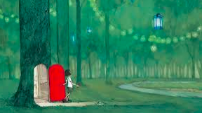
Terrific Topic
GARDENER’S WORLD
This Half Term we will be learning about Gardens and Parks in our community and the Wider World.
Our focus this week is – Parks

- What is your favourite equipment at the park ? Design your own park with all the equipment you like – swings, slides etc. Have you thought about your parents? Where will they sit?
- Make a model of your park.
- Fly a kite at the park
- Design a kite
- Invent a game we could play at the park when we see each other again.
- Read Percy the Park Keeper and complete the activities.
- There are lots of National Parks in the UK including the Southdowns National Park which we are part of. Can you choose one to research. Produce a poster/leaflet/powerpoint about the park.
- Walk a stretch of the Southdowns National park.
- Use sticks to complete some tracking in the woods with your family. Use the symbol sheet to help you.

Marvellous Maths
Brain boost: Year 2
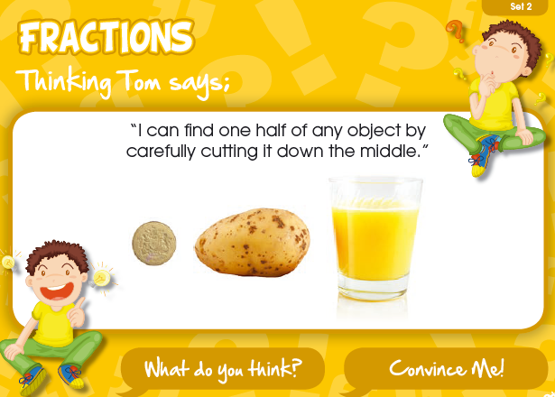

Year 2
This week we would like you to learn about fractions.
You will have three sessions which you can either day over three days or split and do a little bit daily.

Day 1:
- Start by reading through the learning reminders below.
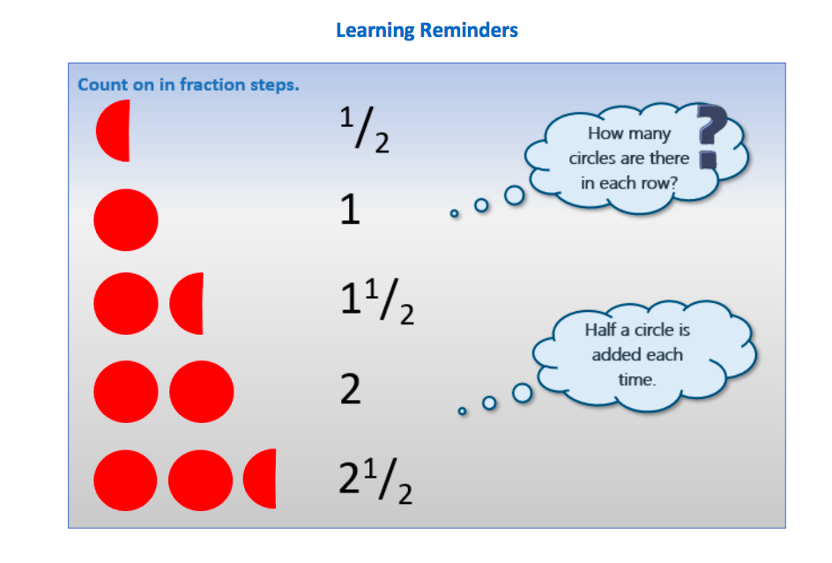

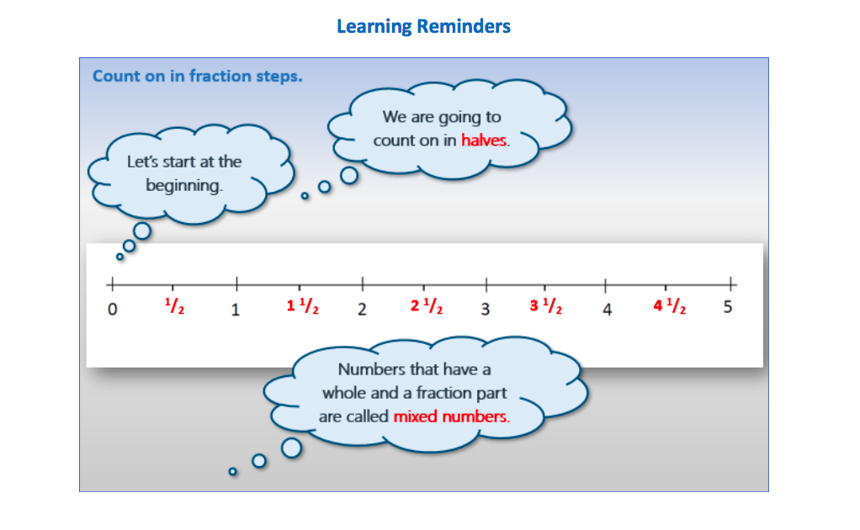
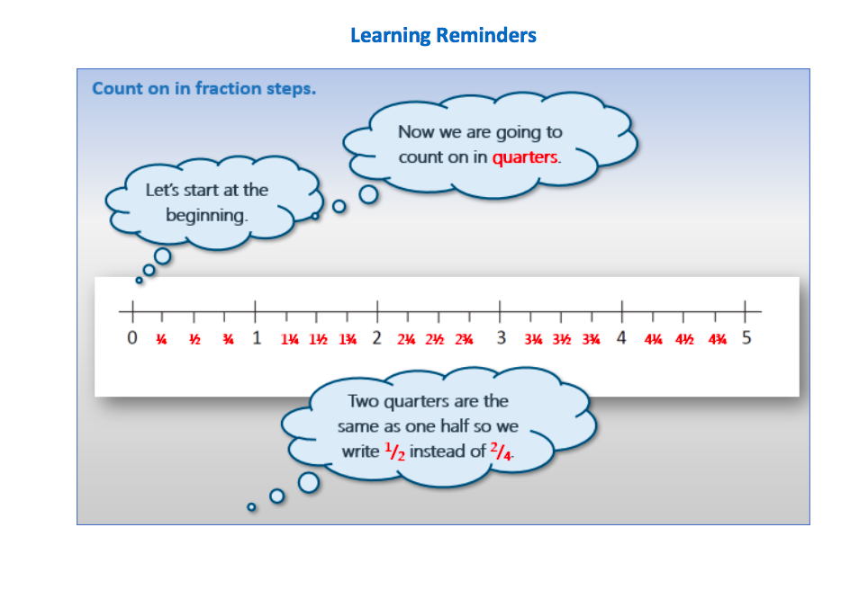
- Work through the day 1 sheet and complete the sheets provided.

Day 2:
- Watch the day 2 power point.
- Read through the day 2 sheet and complete the sheets provided.

Day 3:
- Work through the day 3 sheet and complete the activities.
Brain boost: Year 3
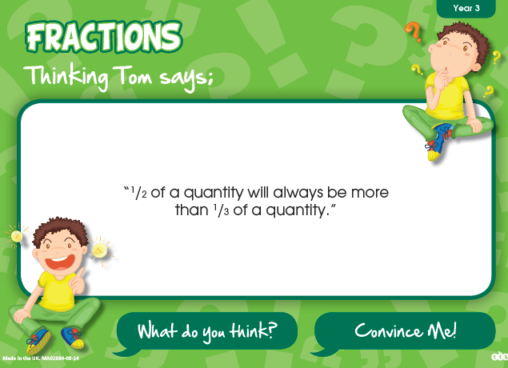

Year 3:
This week we would like you to focus on fractions.
You will have three sessions which you can either day over three days or split and do a little bit daily.

Day 1:
- Watch the year 3 day 1 powerpoint.
- Work through the day 1 sheet and complete activities.

Day 2:
- Work through the day 2 sheet and complete the activities.

Day 3:
- Work through the day 3 fraction cards.

