The Magic Doorway

Look carefully at the picture of the magic doorway.

Write 10 questions that you would like to have answered about the land beyond the door.

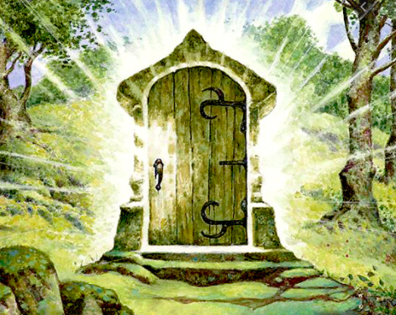
1.

2.

3.

4.

5.

6.

7.

8.

9.

10.

