Marvellous Maths
Brain boost: Year 2: Maze (see resources on the website)

Year 2
This week we would like you to focus on subtraction. They will learn how to subtract using the partitioning method or, in session 2, can use either the partitioning method or counting back.
- First of all ask your child to complete p23 of the CGP Targeted Study and Question Book as revision from last week. There is an explanation of the methods used last week on p22 if needed.
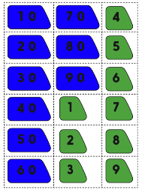
- To use the partitioning method for subtraction, your child must make up each 2 digit number using the arrow cards from last week. They then need to group the tens numbers together, then the ones. Next they need to subtract the 10s then subtract the ones. Finally they need to add the remaining tens and ones to get the answer.
The CGP Targeted Study and Question Book p24 shows the breakdown of this method:
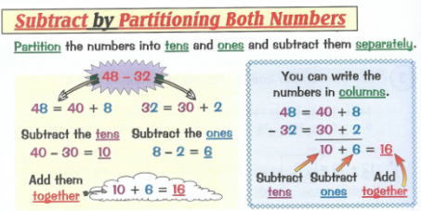
Added to the website is a subtraction practice sheet or you can generate your own calculations. You will need to make sure that the ones in the second number are smaller than the ones in the first number e.g. 46-21
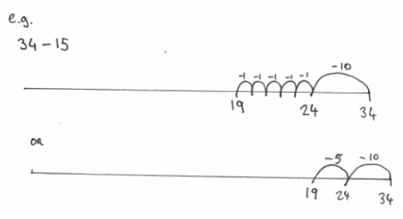
- Today your child will use a number line to subtract pairs of 2 digit numbers. For this method, your child writes the largest number at the end of the number line. They then split the second number into 10s and 1s. They first jump back the tens (either individually or as one big jump) and then jump back the ones.
As in session 1, there are some practice questions to consolidate their learning or your can generate your own. They can use either method to solve them or use a combination of both methods.

- Ask your child to complete p25 of the CGP Targeted Study and Question Book.

Brain boost: Year 3:
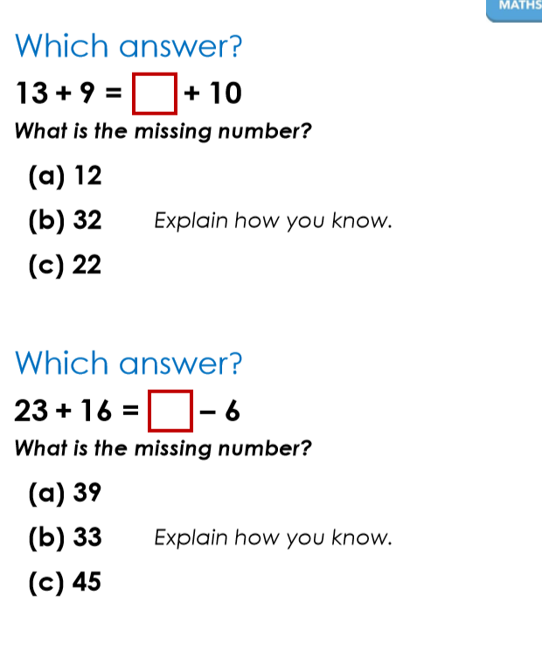

Year 3:
This week we would like you to focus on subtraction. We would like your child to be able to subtract numbers with up to 3 digits using a written method but also be able to subtract numbers mentally.
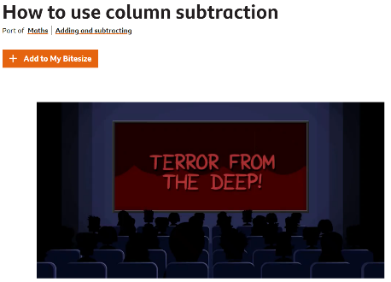
1. Go onto the BBC Bitesize website https://www.bbc.co.uk/bitesize/topics/zy2mn39/articles/zc78srd and this should take you to the “How to use column subtraction” page. Your child has already been taught column subtraction so this will hopefully already be familiar to them. Work your way through this page watching the clip and then completing the activities.
This is how we teach and layout column subtraction in school:
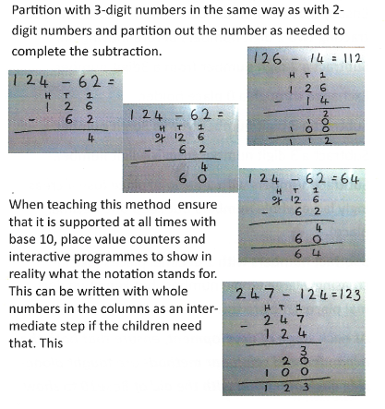
If your child is struggling with “exchanging” then go back to using digits where exchanging is not necessary until they are more confident with this method. For some children you will need to start with 2 two-digit numbers, others will be ready for 1 or 2 three-digit numbers and some might like the challenge of four-digit numbers! You know where your child is most comfortable. I have added some practice sheets to the website but please feel free to generate your own or ask your child to create their own.

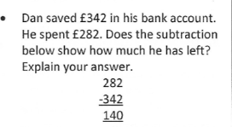

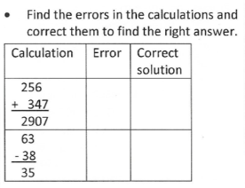

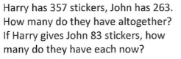

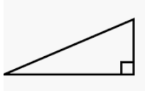

- Play “Find the Number”. The instructions are on the website.

