Comparing the Book and Film

 | Characters/ Setting | Problem/ Resolution | Things that were different | Things that were the same | I liked... because...
Book

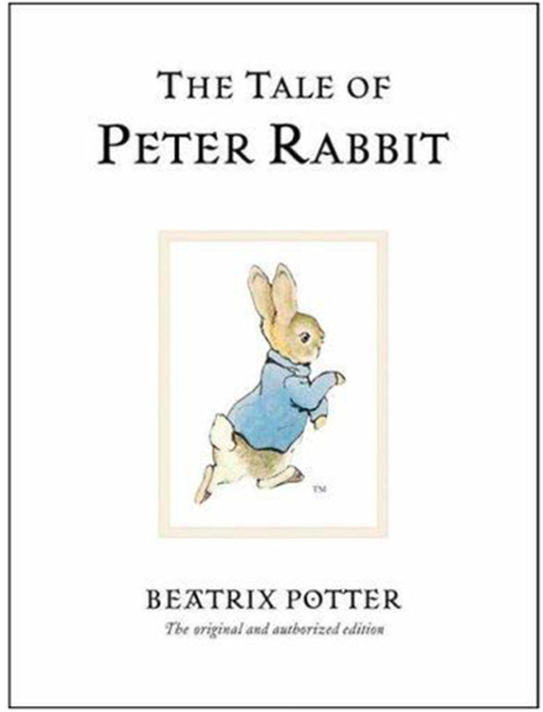

Film



