Peter Rabbit
Character Description

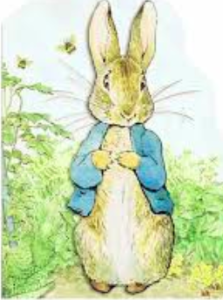
Appearance:

Personality:

Crimes:

