

HAMPSHIRE SCHOOL GAMES

PRIMARY DAILY CHALLENGE – WEEK SIX: 22nd – 26th FEBRUARY
- FOCUS OF THE WEEK: EMPATHY
TO UNDERSTAND AND SHARE THE FEELINGS OF ONE ANOTHER

Name: Year Group: School:


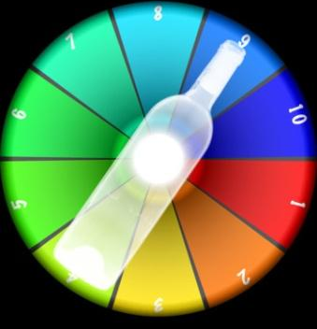

Warm Up Game – Spin the Bottle

- You will need a bottle and either 10 cards or create a numbered board like this!
- Spin the bottle!
- Whichever numbered activity the bottle top is pointing to you have to complete the task – see below
- Choose one of the challenges below. You may want to complete a different challenge each day, or even create your own!
CHALLENGE 1: How many can you complete in a set time?
CHALLENGE 2: How long does it take to complete all 10 numbered
activities?
FAMILY CHALLENGE 1: Spin the bottle for each other.
FAMILY CHALLENGE 2: How long does it take to complete all 10 numbered
activities together?
TASK
1: 20 x Butt Kicks 6: 10 x Second Sprint
2: 20 x High Knees 7: 10 x Burpees
3: 10 x Jumping Jacks 8: 10 x Tuck Jumps
4: 10 x Jumping Lunges 9: 10 x Mountain Climbers
5: 10 x Side Lunges 10: 20 x ‘Spotty Dogs’

As part of Empathy Week the Hampshire School Games Organisers are using the Inclusion 2020 Learning and Discovery Personal Challenge Days at Home activities.


