 Buriton Sports
Friday 24th January 2020/Edition1
Newsletter
Written by Year 6

On Wednesday the 13th of November year 3 and 4 had a football match at Bedales, which was organised by Miss Eades. They managed to score 4 goals (by Max, Adam, Jayden and George.) Max Hobby year 4 said: “It was inspiring and we would love to go there again, we all had so much fun. We had a great day and it was a great tournament.”

We’ve heard that there is a cool hockey club in Bedales school in Petersfield that one of our class members Jacob Cook goes to. It’s on Sunday 10:00am – 11:30am. We think that this club will inspire lots of people to do hockey.

SCHOOL SPORTS CLUBS

Lunch times
Monday Lunchtime Tennis (agreed with Paul Evans)
Tuesday Lunchtime Core Football Yr 5 & 6
Tuesday Lunchtime Core Football for Yr 3 &4
Wednesday Lunchtime Core Dodgeball Y 5 & 6
Wednesday Lunchtime Core Dodgeball Y 5 & 6

Afternoon play times Table tennis for Years 3 & over on a rota basis

After school
Tuesday Core Multisports KS1
Tuesday Football Training with Paul Wakeford KS2
Wednesday Core Multisports KS2
Wednesday tennis with Paul Evans
Thursday Fencing with JC Sports (yr 2 and over)
Friday Core Football KS2
Friday Cross Country Running with Sarah Osman for Yr 3 & over

THIS TERM’S FIXTURES

Friday, 31st January 2020 – Cross Country Race at Portsdown Hill
(No after school cross country club with Sarah Osman 31.1.20)
Friday, 14th February 2020 – Cross Country Race at Portsdown Hill
Friday, 6th March 2019 – Cross Country Race at Crookhorn

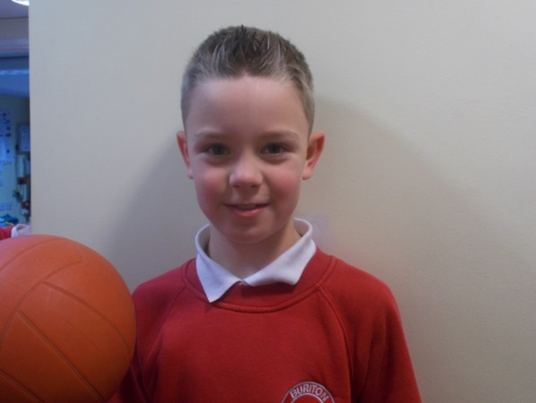
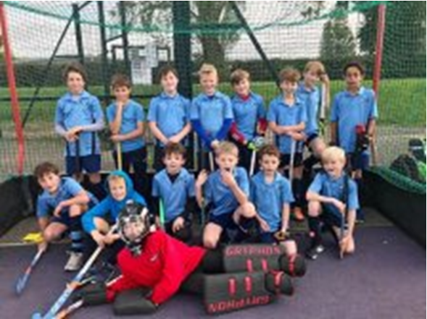

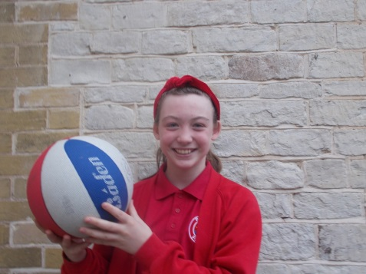Our sports person of the week is Zoe Spencer, as she is a great team player, and shows amazing sportsmanship. She always wants to learn and she is super at all sports and games. Zoe is one of our best sports players and is always up to a challenge in P.E.

Football Festival
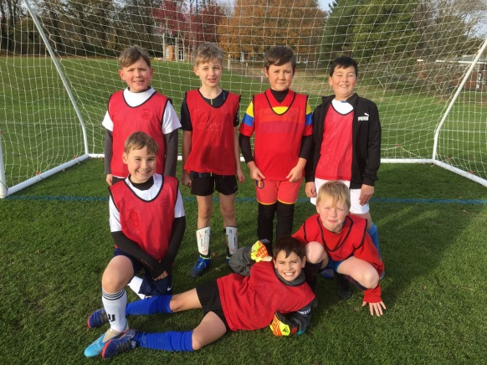The year 6 and 5s went to a football festival at Bedales, there were 8 matches and the year 6 team won 1 match and drew against the year 5 team. Well done Buriton!!

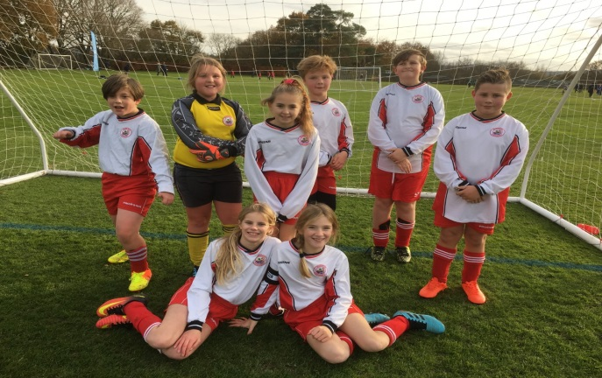

Play Time Leaders
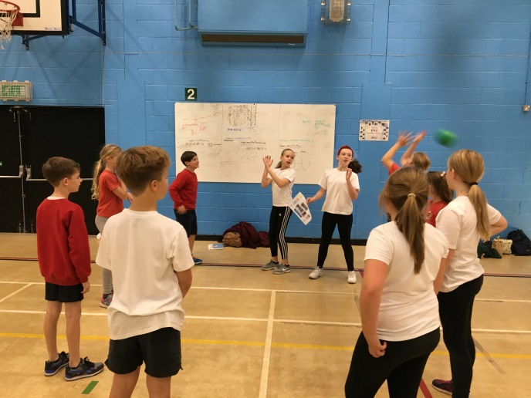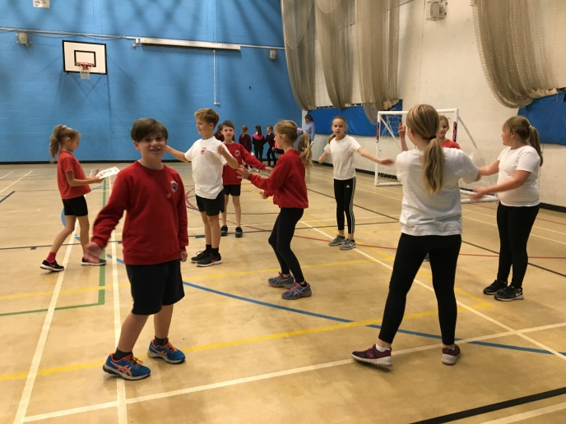Quite a while ago (back in October) a few of the year 6s went to a Play Time Leader workshop to bring it back to school, so that everyone can have a go at games. Everyone had a bundle of fun! We are looking forward to using this in school.

FUNNY FRIDAY
Q. DID YOU HEAR ABOUT THE RACE BETWEEN THE DOG TAP AND TOMATO?
A. THE DOG WAS IN THE LEAD, THE TAP WAS RUNNING AND THE TOMATO WAS TRYING TO KETCHUP.
Q. WHATS THE WORST SPORT?
A. BADMINTON
Q. WHAT DID THE BASEBALL GLOVE SAY TO BALL?
A. ‘CATCH YOU LATER!’
Q. WHAT A GHOSTS FAVROUITE FOOTBALL POSTION?
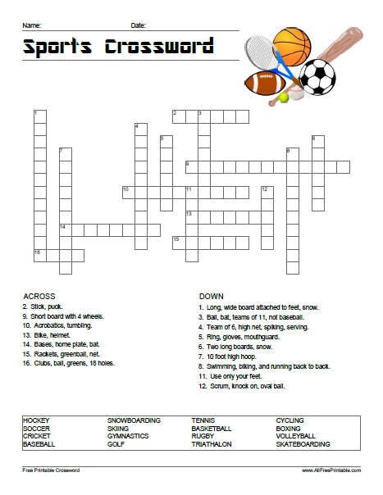A. GHOUL KEEPER

